**Microsoft Visual Studio 2019**

Our first task is to get to know the development environment.

Some of you may already be familiar with the Microsoft Development Environment from previous papers or your own research.

In this session we will look at the basic operation of the platform, a C# Universal Windows Platform (UWP) application project template and finally some of the extended features of the Integrated Development Environment.

*Note: You will make your own project for this session and then look at the demo project* ***UWPApplication1*** *for reference.*

**Opening** **the Development Environment**

To open the Microsoft Development environment select the following.

Click the on the **Windows** 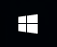 button in the lower left corner of your screen or press the  **Windows Key** on your keyboard.

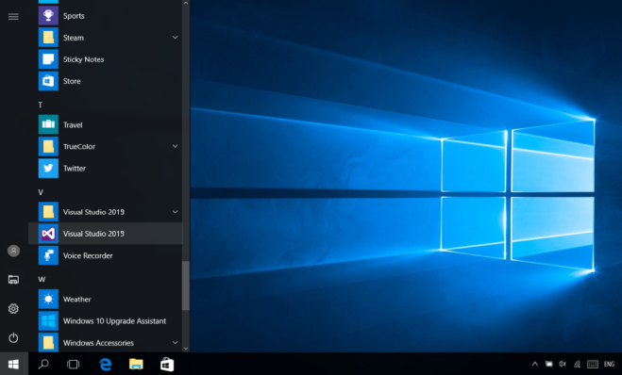

When the programs list appears.

Scroll down the programs list until you reach the **V** section and then select (by clicking on it) the **Visual Studio 2019** application.

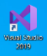

Note: You can also search for Visual Studio 2019 in your search window or click on the shortcut if you have one on your desktop.

The Visual Studio load screen will appear and the application will load.

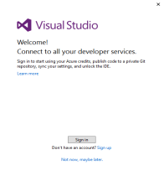

When the insulation is complete you may be asked to connect up all your developer services, for now just select the **Not now, maybe later** option by clicking on it.

**Opening** **the Development Environment for the First Time**

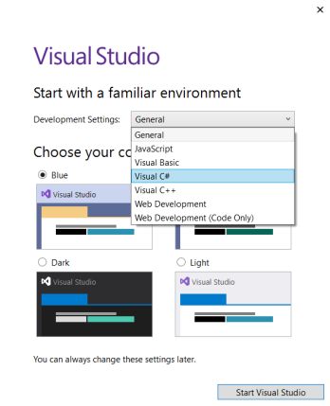

If this is the first time that you have used the Development Environment then the **Start with a familiar environment** window may appear.

This will give you some options to configure the environment to a specific language, setup and feel.

Select **Visual C#** from the **Development settings:** list.

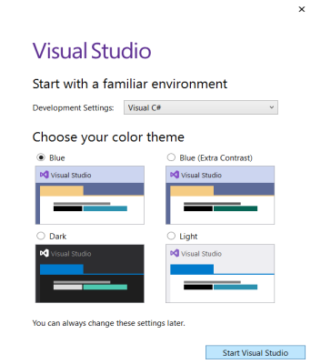

Select the **Blue** option from the **Choose your color theme** options.

Click the Start Visual Studio button to open the development Environment.

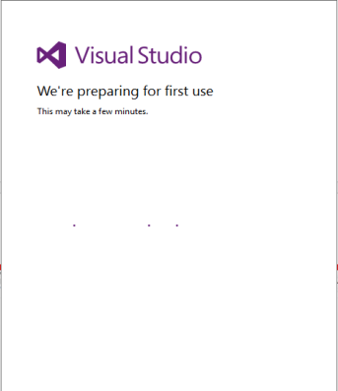

It will take a while to configure the environment.

As the prompt will tell you.

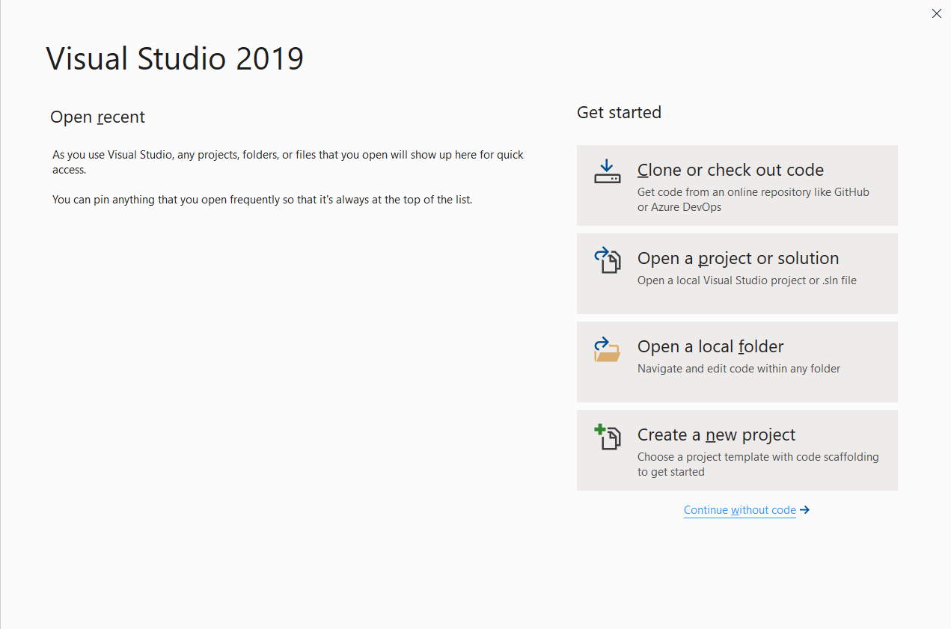When the Visual Studio 2019 screen appears click the ‘**Create a new project**’ button.

At some point the **Create a New Project** screen will load up, allowing you to select a project type to work with.

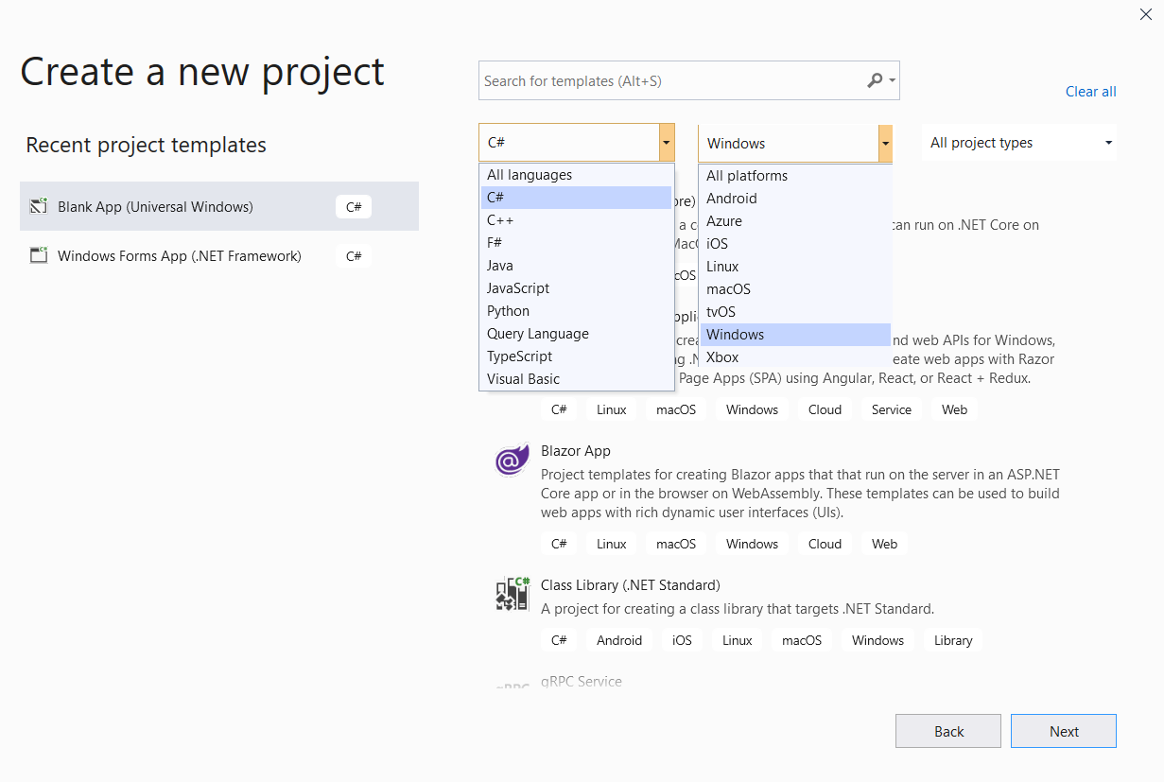If this is the first time you have created a project select **C*#*** and **Windows** from the search list options. This refines the list of project builds for you.

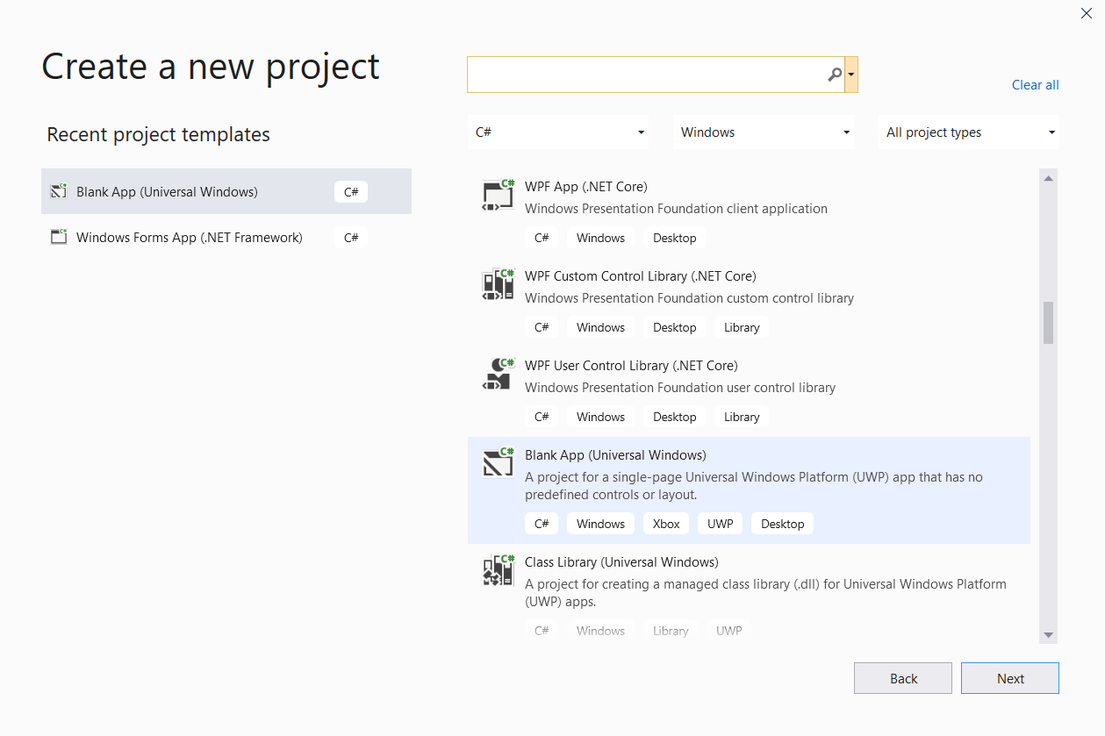We will be building a Universal Windows application so click the **Blank App (Universal Windows)** option and then click the **Next** button.

When the **Configure your new project** window appears, enter a name for your project in the **Project name** text box (I used UWPApplication1), type a location for your project file in the **Location** text box or use the directory finder **… button** thentick the **Place solution and project in the same directory** check box.

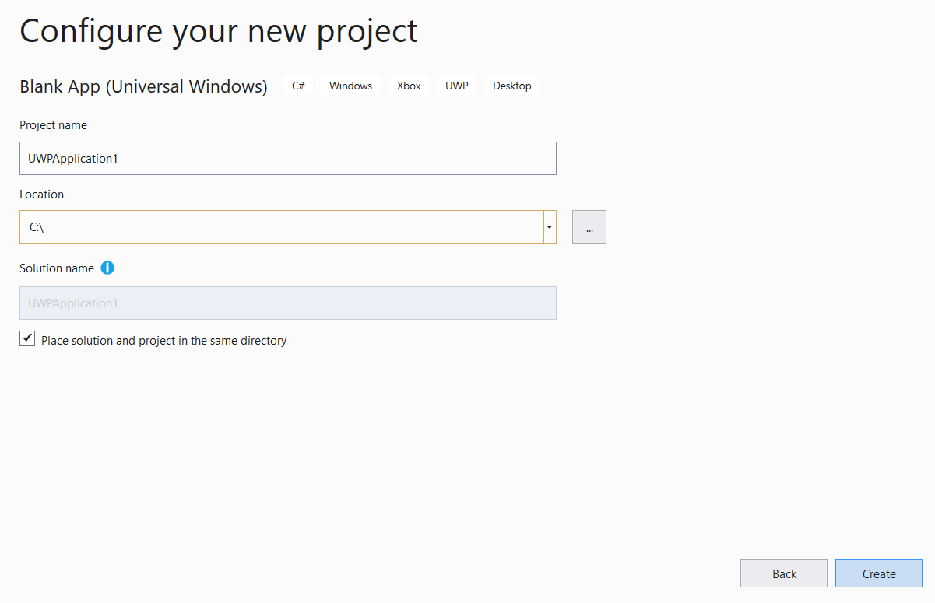When you are happy with your name and location of your project click the **Create** button.

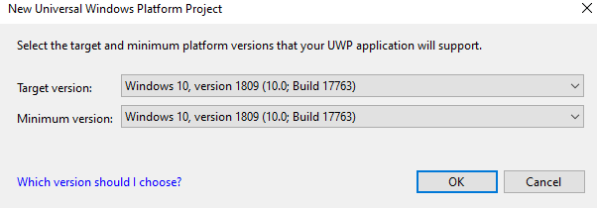Your projects should be built on the latest (or close too) Windows 10 version - the system in class should be set up for you.

So click **OK** when the build version window appears.

In the labs we will use the **Windows 10. Version 1809(10.0;Build 17763**) for both.

Note: If you are using your own laptop - see the notes in ***Appendix A For Home Use*** under the ***Checking the build and setting the developer mode*** section.

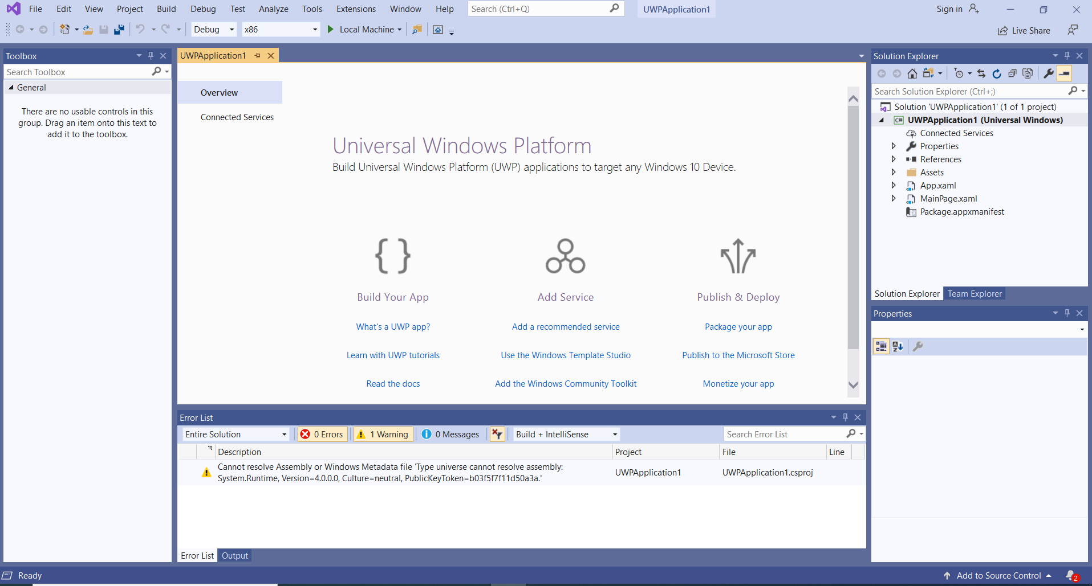At this point the development environment will load…

**The Development Environment**

When developing applications in the Microsoft environment there is a large set of project templates that can be used to set up project types quickly. The development done during this part of the course will focus on the **Universal Windows Platform** (UWP) project type (this will allow us to develop interfaces and also provide a basic application to add our code).

We currently have the environment loaded, but let’s look at an alternative way of opening a project. This project type can be accessed as a ‘Project Type’ from the ’New Projects’ menu in the Integrated Development Environment and offers a pre-made entry point for developing C# applications using Universal Windows Platform interfaces.

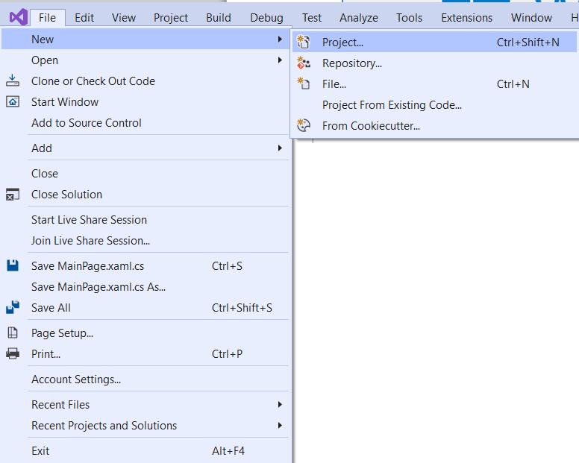**Creating a UWP Project**

To create a project, open visual studio and then select the **File > New > Project…** option.

This opens the **Create a new project** window. As we are building a Universal Windows application click the **Blank App (Universal Windows)** optionand then click the **Next** button.

When the **Configure your new project** window appears, enter a name for your project in the **Project name** text box (I used UWPApplication1), type a location for your project file in the **Location** text box or use the directory finder **… button** thentick the **Place solution and project in the same directory** check box.

When you are happy with your name and location of your project click the **Create** button.

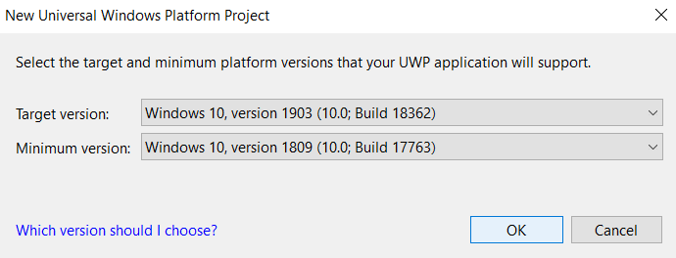

Your projects should be built on the latest (or close too) Windows 10 version - the system in class should be set up for you.

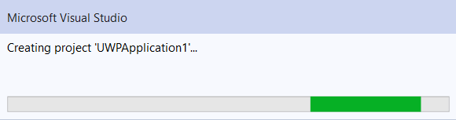So click **OK** when the build version window appears.

During configuration the Microsoft Visual Studio load up screen may be displayed.

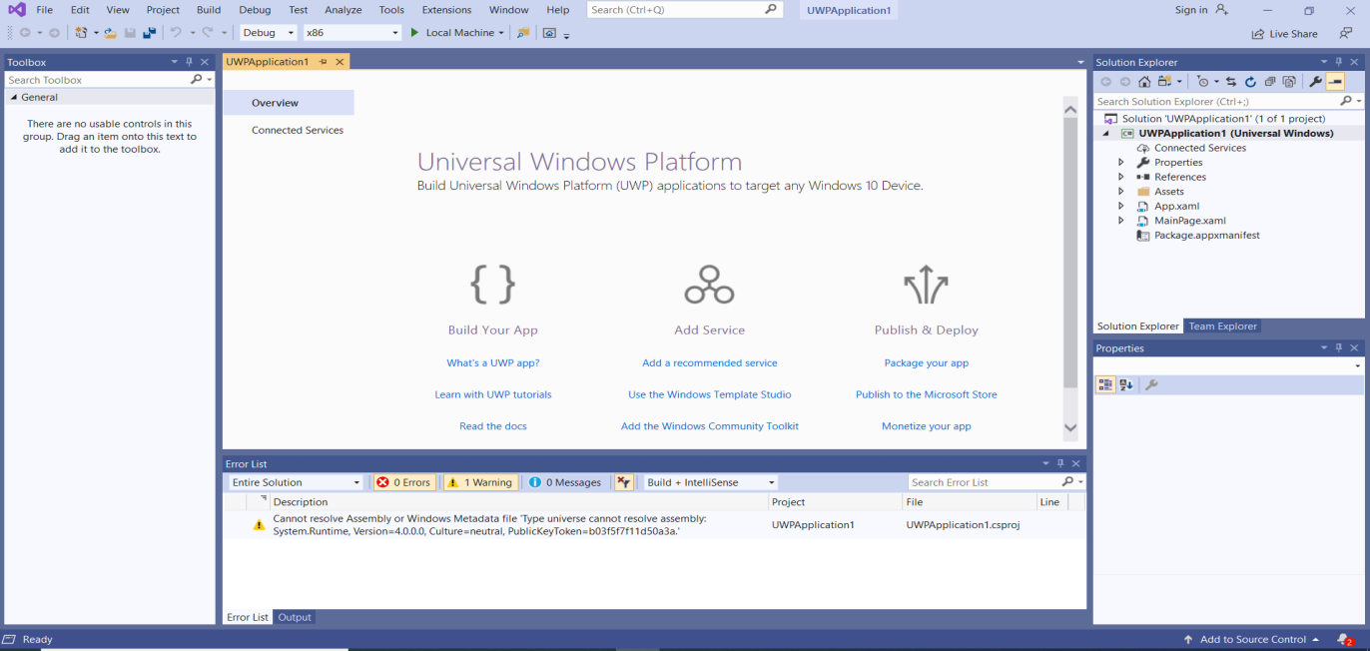At this point the development environment will load…

**Saving a Project**

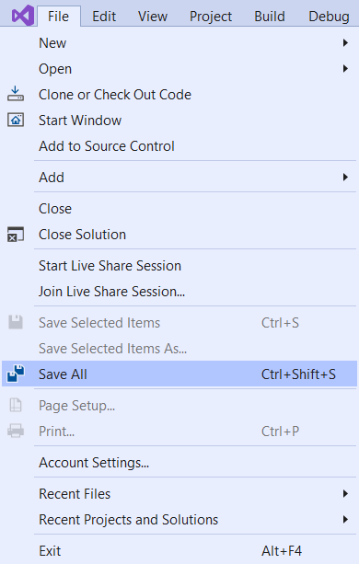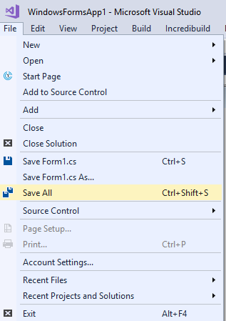The **File > Save All** option can be used to save the project as you work on it to the folder set up when the project was created.

The project is saved automatically (to the folder set up when the project was created) every time the project is ***built*** or ***run***.

So ***be careful*** work is not overwritten that you wanted to keep.

Note: Save several versions of larger projects as you develop them so as to retain older copies of your code.

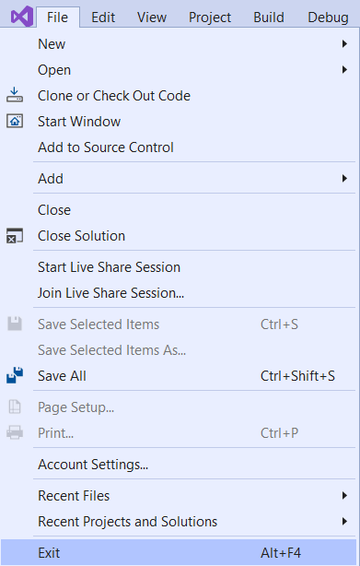

**Closing a Project**

A project can be closed using the **File > Exit** option, on the keyboard by using Alt+F4 or by clicking the Project Workspace **X** button.

Note: The project is ***not saved*** automatically when you exit so be careful to save your work before you exit.

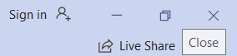

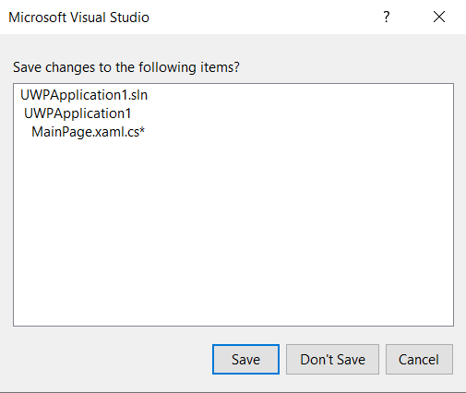

If you have made changes to your code the save reminder prompt should appear, make sure you select the **Save** button option to save your work.

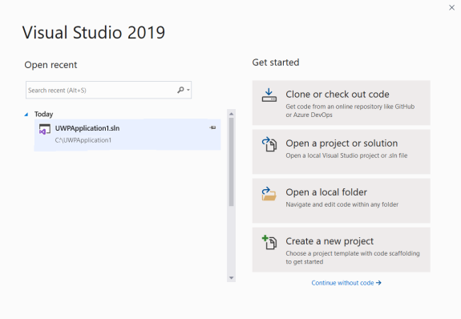**Opening an Existing Project**

This can be done in several ways

From the start screen, by selecting a project from the Open **resent** project list.

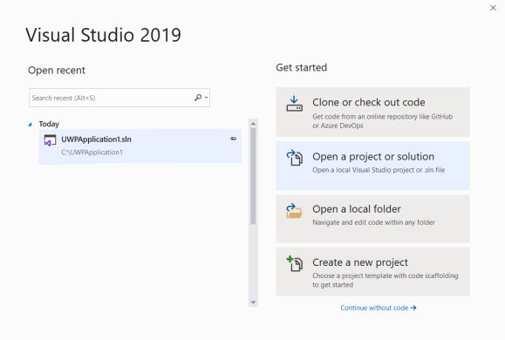

From the start screen, by selecting the **Open a project or solution** option.

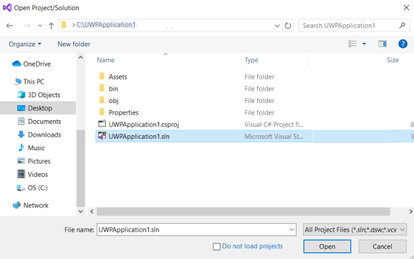

Then navigating to the correct project folder, selecting the **.sln** file and clicking on the **Open** button.

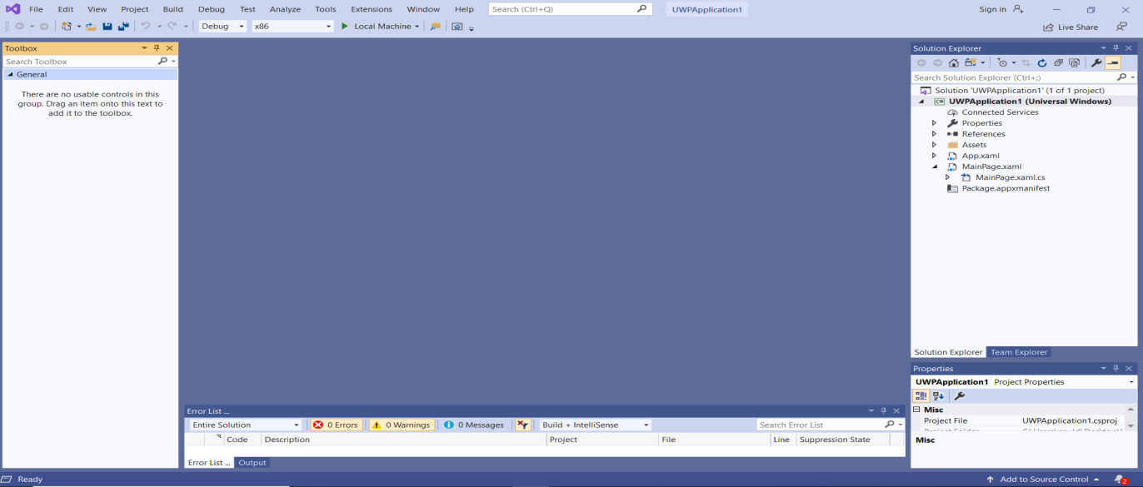An existing project can be opened from the main page of the IDE.

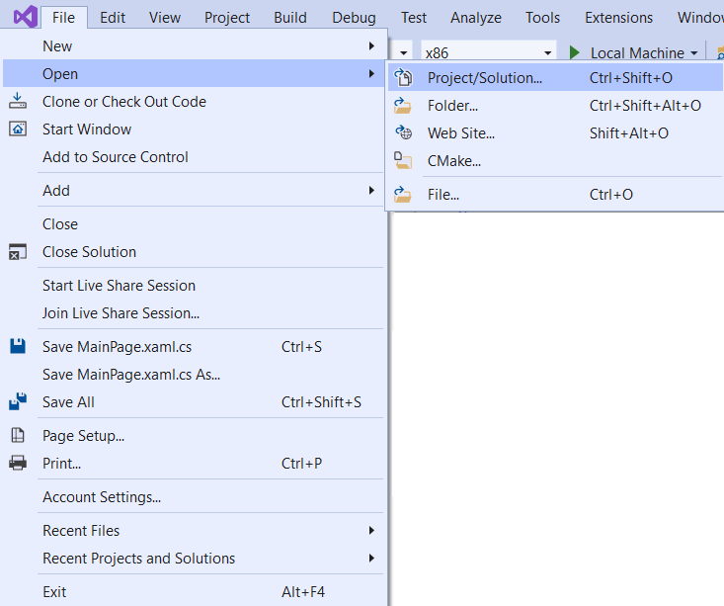When inside **Visual Studio.**

select the **Open > Project/Solution ….** option and use the **Open Project** navigation window to load the project **.sln** file.

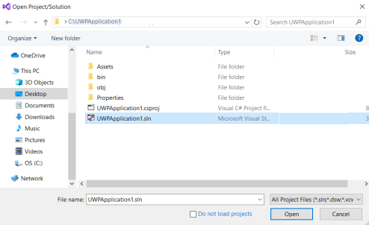

By selecting the **.sln** file and pressing the **Open** button.

**A Quick Way to Opening an Existing Project**

A faster way is to locate the project you want to open in your File Explorer  and then **double click** on the **.sln** file.

**What’s in a Project Workspace?**

Before we start to investigate the IDE, we need to make sure that we have the basic windows present.

Select the **View tab** and **click** on the following options:

* Error List
* Output
* Toolbox
* Properties Window

**Double Click** on the following files in the Solution Explorer window:

* MainPage.xaml.cs
* 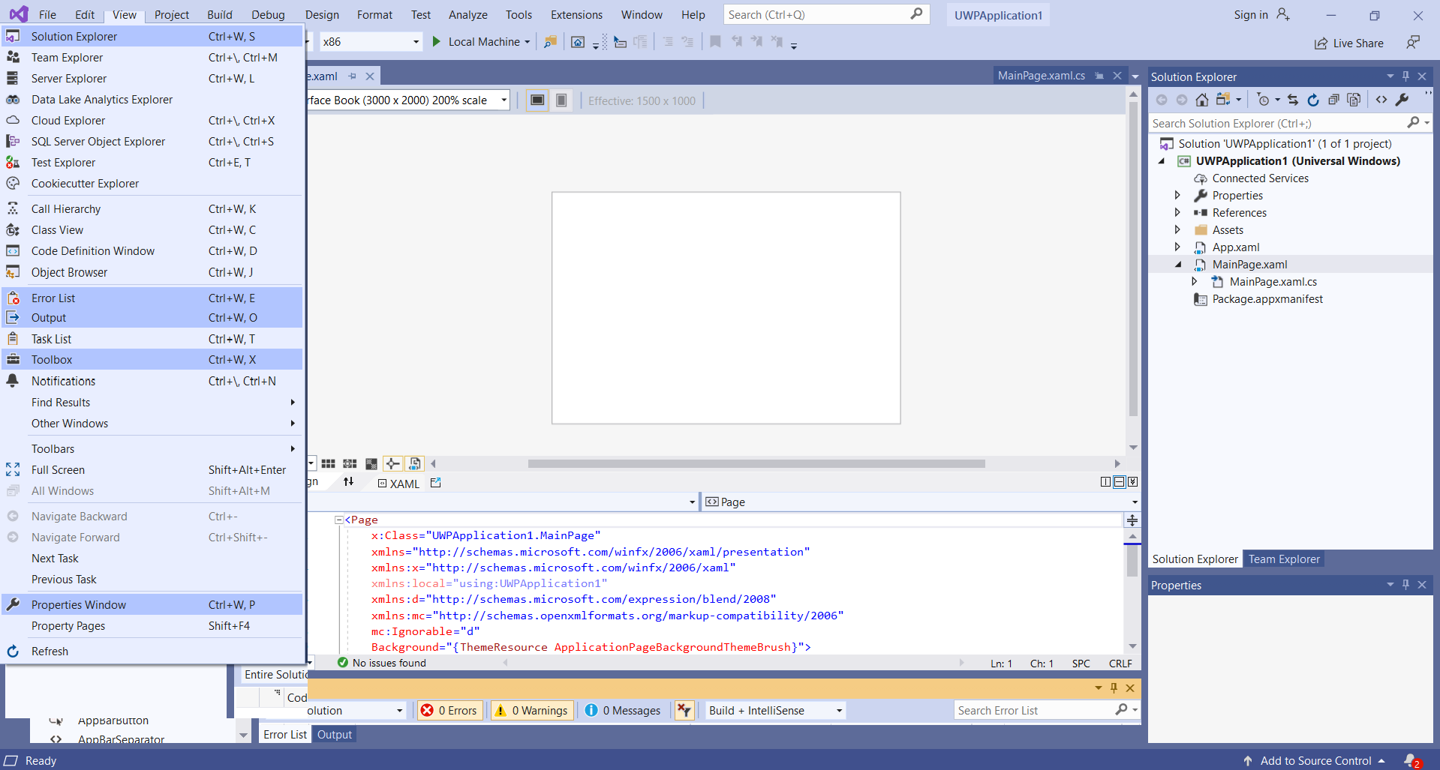MainPage.xaml

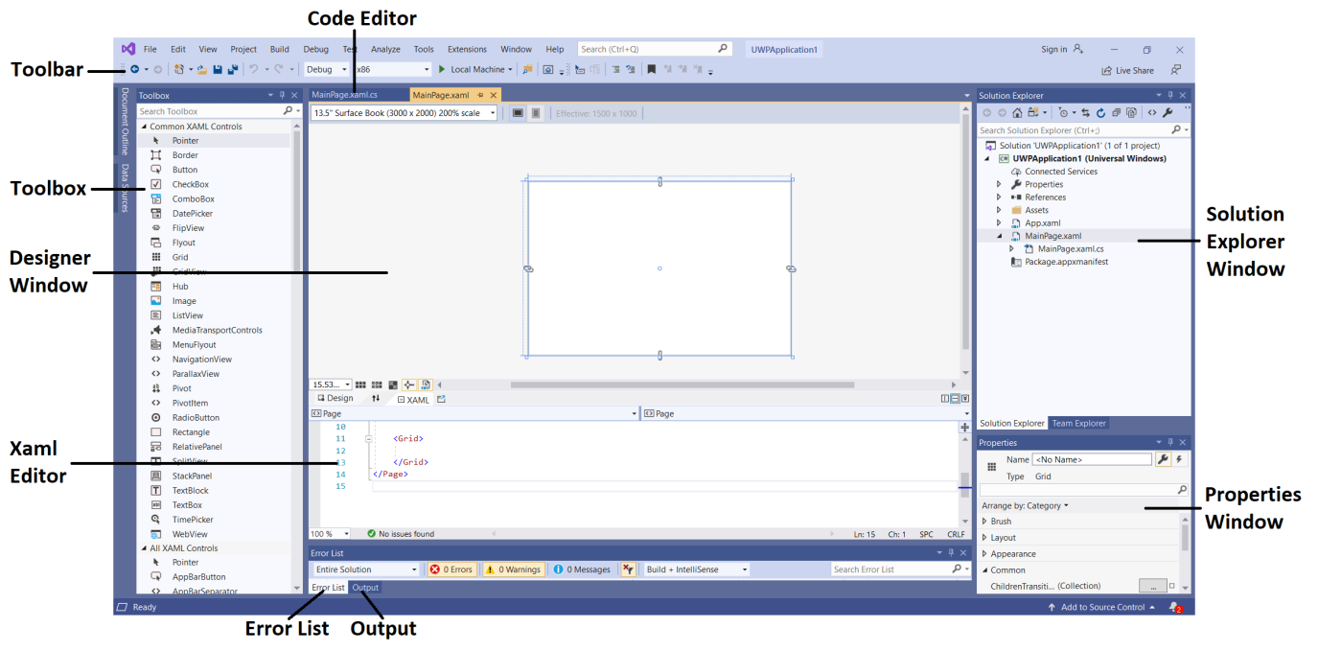You should see the following configuration.

**Moving Between Windows**

To move between the **Design/Xaml** Window and **Code** Window in the IDE (Integrated Development Environment) is simple.

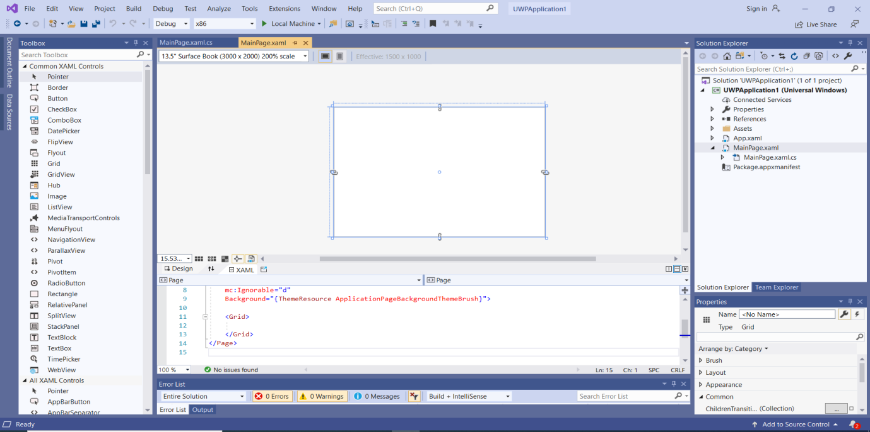We currently have the Design Window visible.

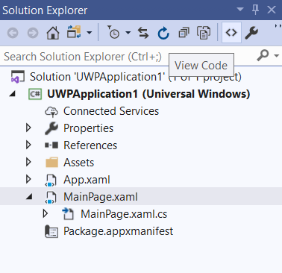

To move between the **Design** and **Code** windows simply click on **View Code**  icon in the Solution Explorer.

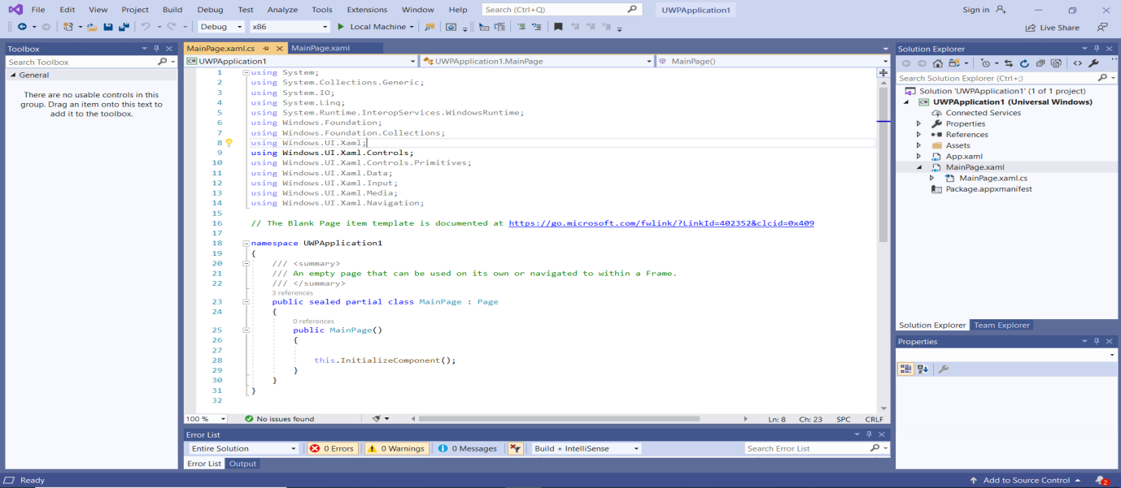The Code Window will be displayed…

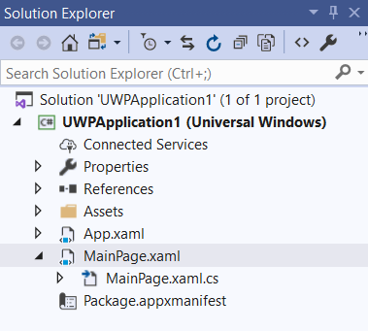To go back to the Design/Xaml Window simply double click on the **MainPage.xaml** file in the solution explorer.

The Design Window will be displayed…….

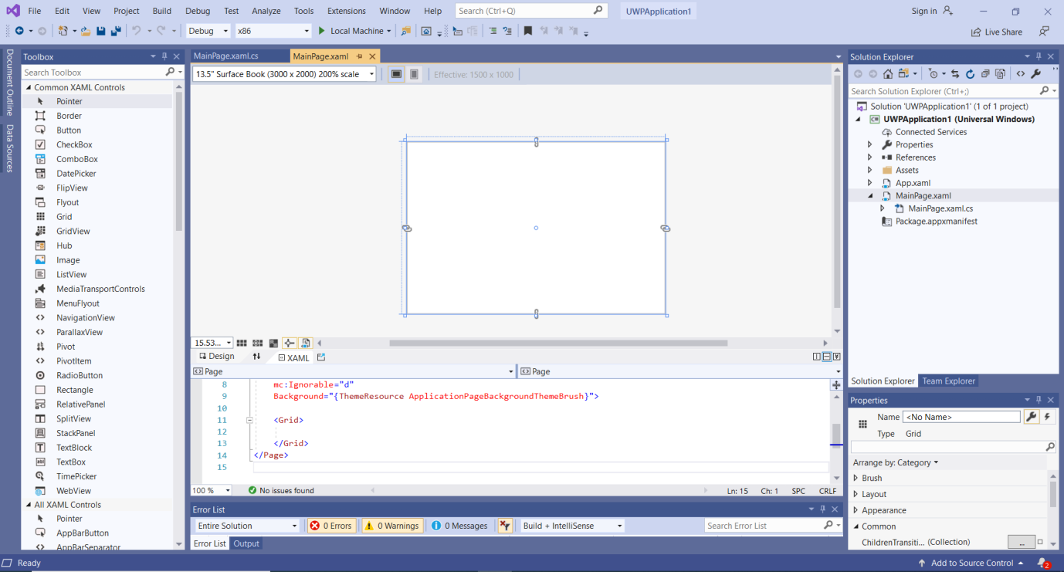Once the windows have been displayed in the Project Workspace they will be a selection of window tabs that you can click on to navigate between windows.

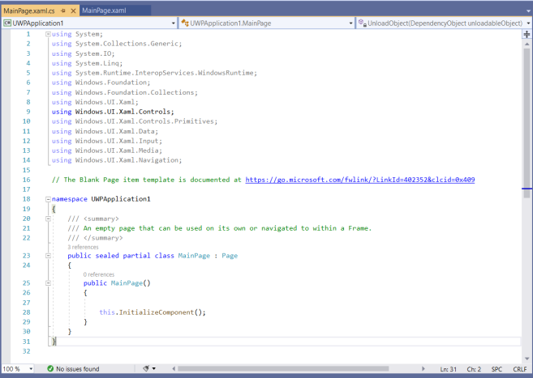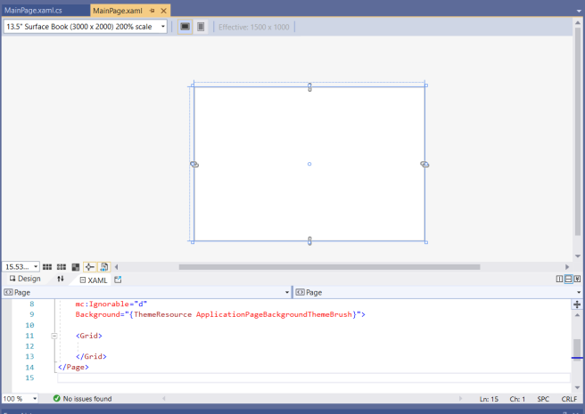Design/Xaml window with navigation tab Code window with navigation tab.

**Working with Visual Studio Windows**

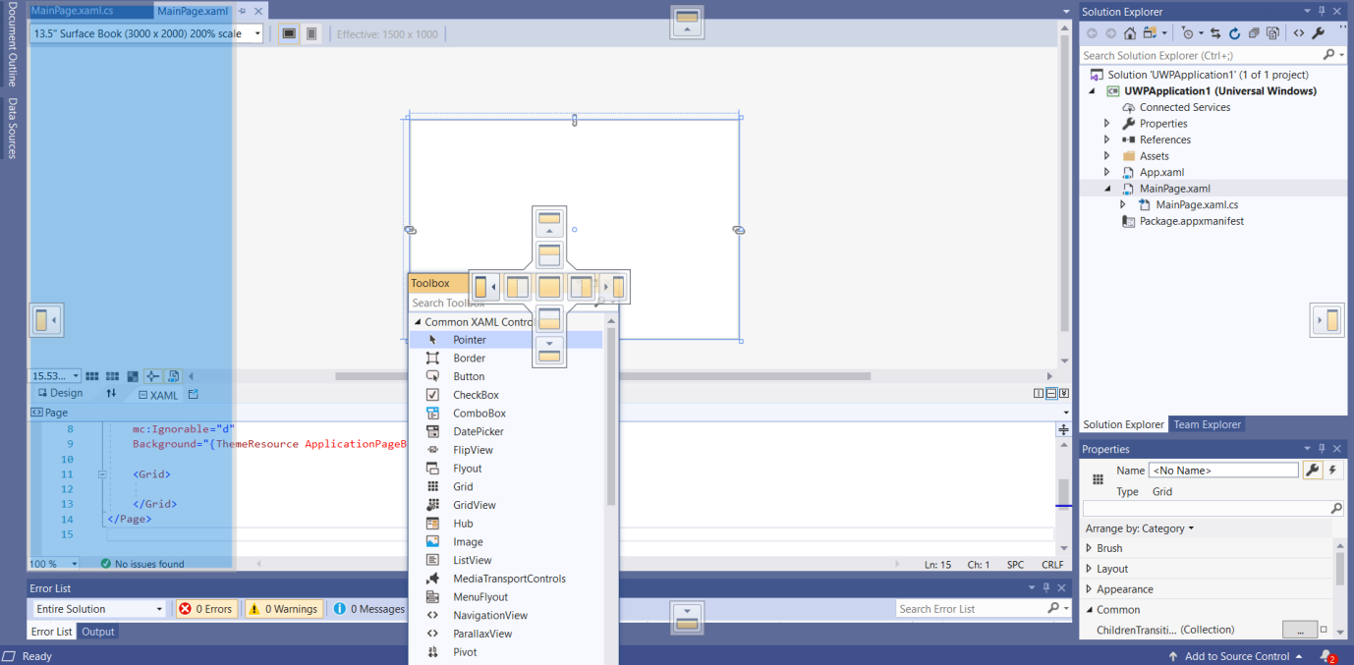Windows can be moved around and docked in the IDE by dragging them by the top of the window panel and placing them on the required setting in the docking icon that appears.

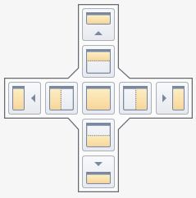

The docking icons have several options allowing you to configure the environment as you like.

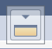Try this out …..

**Using the Solution Explorer**

The Solution Explorer is used to manage a projects files and resources.

When we select a Universal Windows Platform Application for our project type the IDE builds and configures the project for us.

There are seven components that make up a project and we will look at them as we progress through this course.

Our primarily concern will be the Page Designer / Xaml editor (MainPage.xaml) and the associated C# source file (MainPage.xaml.cs) as these are the main sections of the project template we will be working in.

The Assets folder is used to store any resources used in the project image files etc. and any dependency libraries are listed under the References folder.

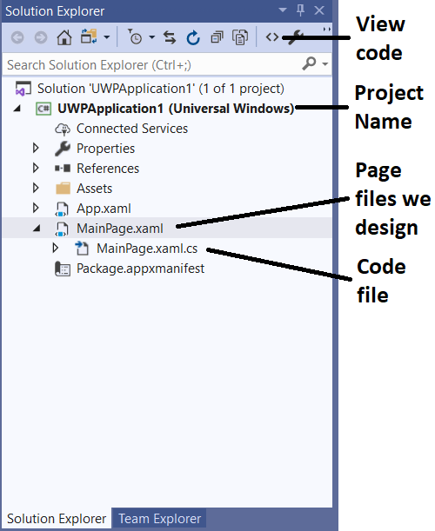

Files are displayed under the Project in a tree structure with a drop down feature used to expand  or collapse  file groups.

File groups can be opened and closed by clicking on the triangles next to them. Individual files can be loaded into the IDE and viewed by double clicking on them.

Several files are required for a project build, the main files of interest to us are the Page Designer / Xaml (MainPage.xaml), and associated C# source file (MainPage.xaml.cs).

**Some technical information**

***What's in the files?***

* Forms are designed in the Design / Xaml Windows (MainPage.xaml) by dragging object from the toolbox or coding objects in Xaml code. The associated C# event code is auto generated for us into the MainPage.xaml.cs file this is also the file where we add our C# program code.
* To view and edit a file in your project, double-click the file in the **Solution Explorer**. Expand a XAML file just like a folder to see its associated code file. XAML files open in a split view that shows both the design surface and the XAML editor.

***XAML***

* Extensible Application Markup Language (XAML) is the language used to define your app's user interface. It can be entered manually, or created using the Visual Studio design tools. A .xaml file has a .xaml.cs code-behind file which contains the logic. Together, the XAML and code-behind make a complete class.

**App.xaml and App.xaml.cs**

* App.xaml is where you declare resources that are used across the app.
* App.xaml.cs is the code-behind file for App.xaml. Like all code-behind pages, it contains a constructor that calls the InitializeComponent method. You don't write the InitializeComponent method. It's generated by Visual Studio, and its main purpose is to initialize the elements declared in the XAML file.
* App.xaml.cs is the entry point for your app.
* App.xaml.cs also contains methods to handle activation and suspension of the app.

**MainPage.xaml**

* MainPage.xaml is where you define the UI for your app. You can add elements directly using XAML markup, or you can use the design tools provided by Visual Studio.
* MainPage.xaml.cs is the code-behind page for MainPage.xaml. It's where you add your app logic and event handlers.
* Together these two files define a new class called MainPage.

**Package.appxmanifest**

* A manifest file that describes your app: its name, description, tile, start page, etc.
* Includes a list of dependencies, resources and files that your app contains.

***References***

* The References section contains references (links) to any assemblies we will use in the project.

**A set of logo images**

* Assets/Square150x150Logo.scale-200.png and Wide310x150Logo.scale-200.png represent your app (either Medium or Wide size) in the start menu.
* Assets/Square44x44Logo.png represents your app in the app list of the start menu, task bar and task manager.
* Assets/StoreLogo.png represents your app in the Microsoft Store.
* Assets/SplashScreen.scale-200.png is the splash screen that appears when your app starts.
* Assets/LockScreenLogo.scale-200.png can be used to represent the app on the lock screen, when the system is locked.

***Reference*** - Microsoft - [https://docs.microsoft.com/en-us/windows/uwp/get-started/create-a-hello-world-app-xaml-universal].

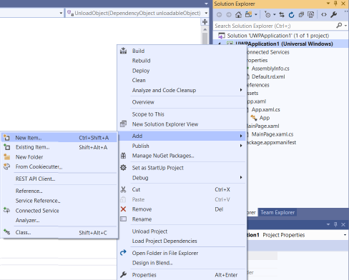**Adding Pages to a Project**

New Pages can be added to a project by **right clicking** on the project name in the Solution Explorer and then selecting the **Add > New Items** option.

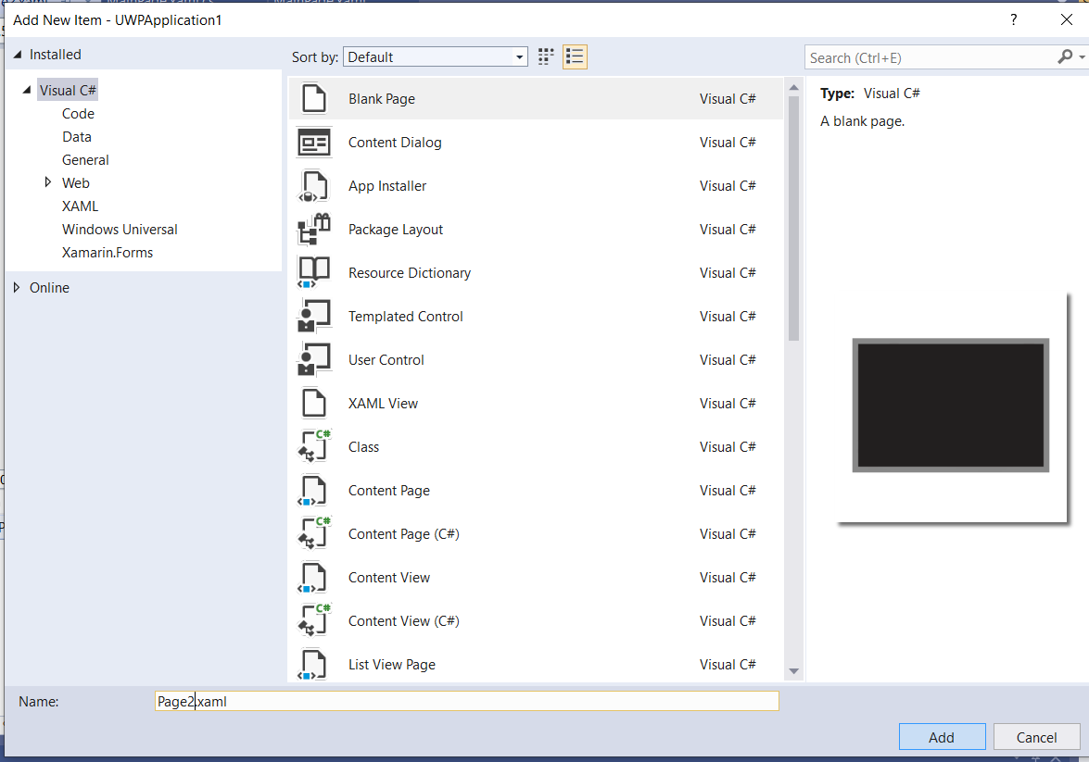This will activate the Add New Items window.

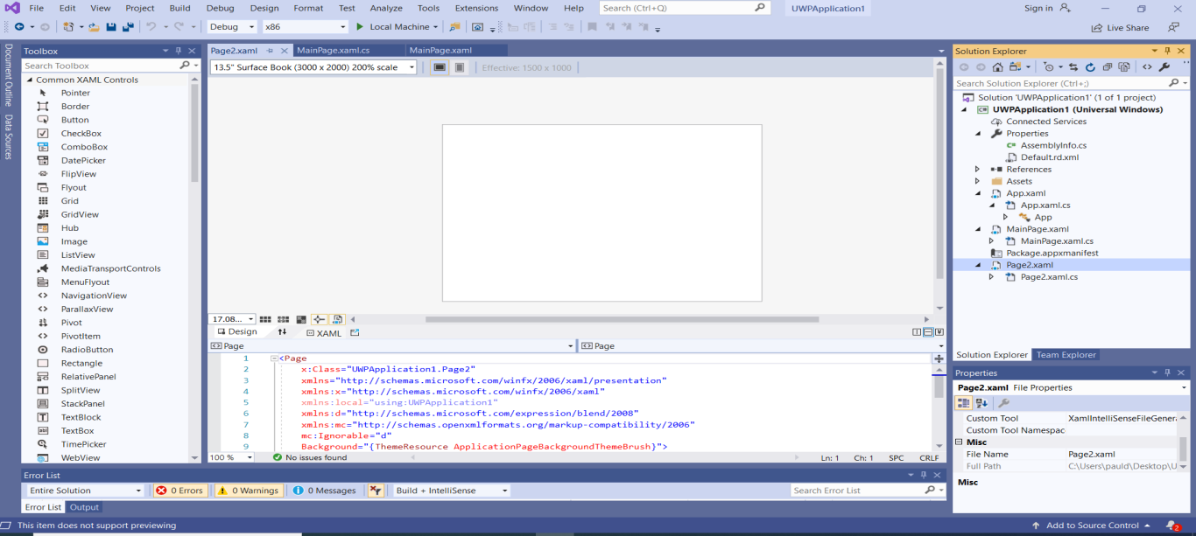Select the **BlankPage** item from the list, in the **Name:** box call the page **Page2** and **click** the **Add** button.

The new form will then be added to the project and displayed. Look in the Solution Explorer, it is now listed there. We can call a Page anything, but we tend to call them something that relates to their functionalityso we can identify them easily in the Solution Explorer window.

**Adding a Class to a Project**

We can add a Class file to our project. This type of file is used for writing C# code in the format of a Class.

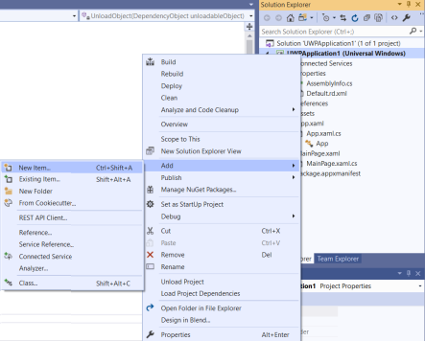Please Note: We will look at classes and the coding of classes in some detail in a couple of weeks. In this section we are concerned with being able to add a class type file to our project using the Solution Explorer.

New classes can be added to a project by **right clicking** on the project name in the Solution Explorer and then selecting the **Add > New Items** option.

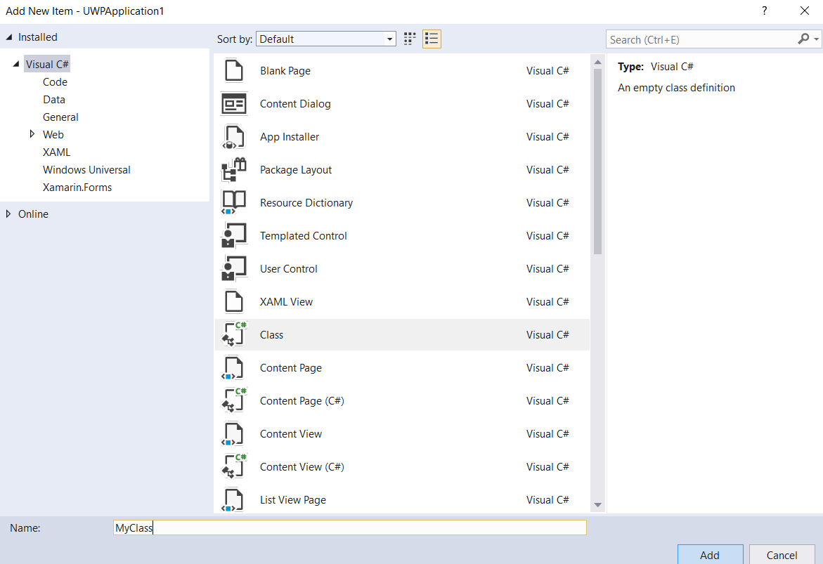This will activate the Add New Items window.

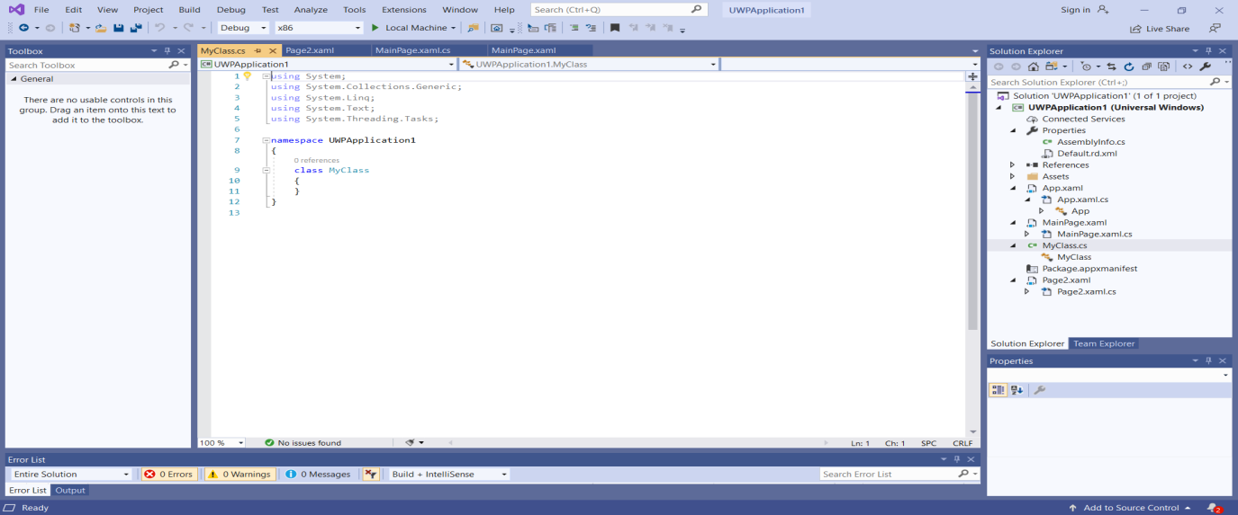Select the **Class** Visual C# item, in the **Name:** box call the class **MyClasss** and then clickthe **Add** button.

The new class will be added to the project. Look in the Solution Explorer for the new MyClass.cs file.

**Adding a Resource to a Project**

We can add a resource file to our project, these tend to be images and graphic files.

Please Note: We will look at resources later in the course in some detail. In this section we are concerned with being able to add a resource to our project using the Solution Explorer.

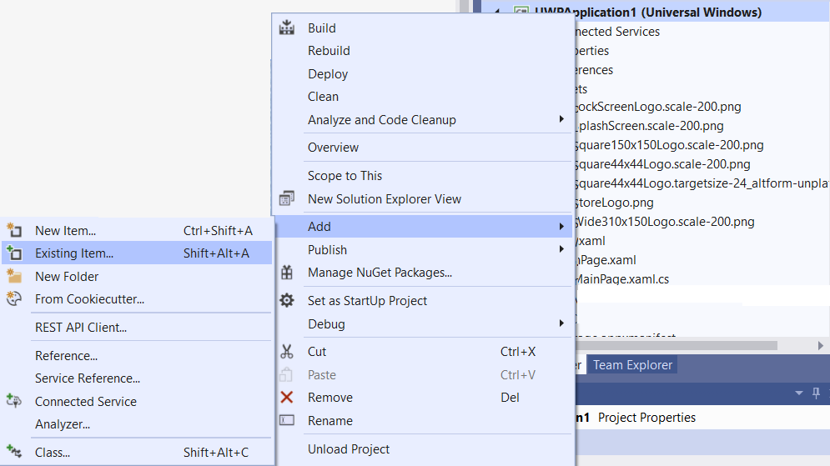

Resources can be added to a project by **right clicking** on the project name in the Solution Explorer and then selecting the **Add > Existing Item…** option.

This will activate the explorer **Add Existing Item** window.

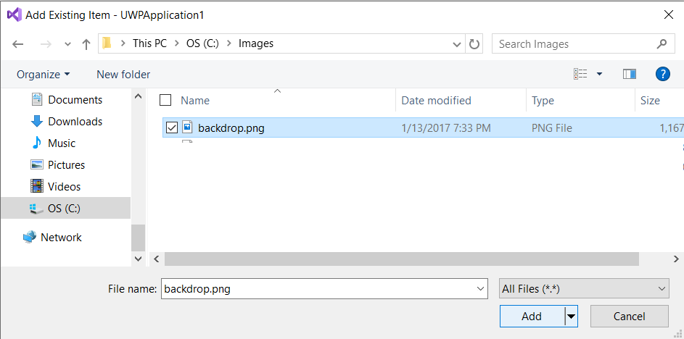

Navigate to your image folder and the image you want to load, then click the **Add** button.

Note: Resources required for any of the course work in this course will supplied with the examples in a **Resources** folder. In this case navigate to the **Resources** folder and select the **backdrop.png** file.

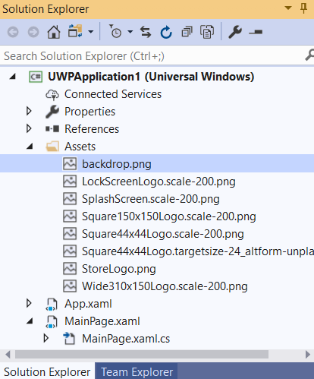

The new resource in this example **backdrop.png** will now be added to the project.

Look in the Solution Explorer under Assets for the new backbrop.png file.

**Using the Page Designer**

We can design Pages with the aid of the Design Window, Toolbar, Properties Window and Xaml editor. Let’s go back to the Design Window by double clicking on the **MainPage.xaml** file in the solution explorer or selecting the **MainPage.xaml tab**.

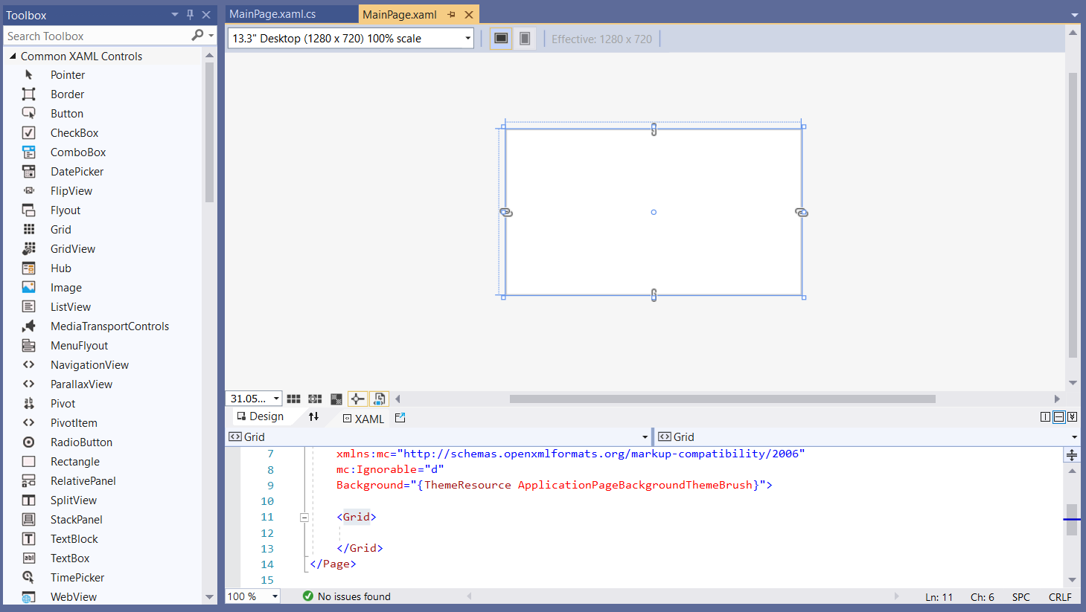Now we will make our page the size of a standard screen by selecting the **13.3 Desktop** option from the dropdown list (top left of the designer window).

**The Designer Window**

In this example we will use the Designer Window and Toolbox to design the interface.

Objects can be dragged from the Toolbar to the Page, there they can be moved and edited. In this example I have set the zoom to 66.67 to make the design page fit in the designer window.

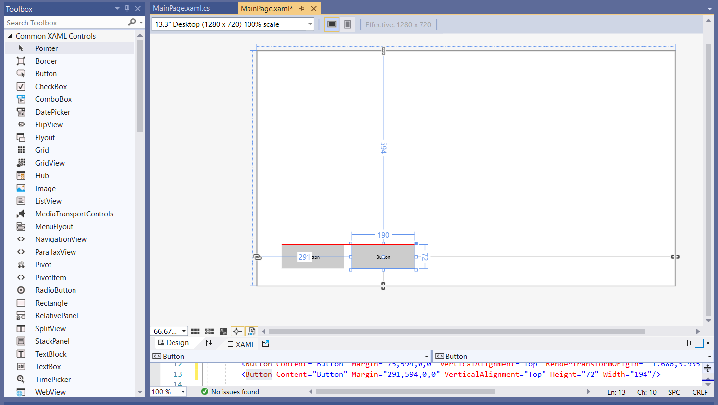

Try adding a couple of buttons to your page………..

Try adding several objects from the Toolbox to your form……….

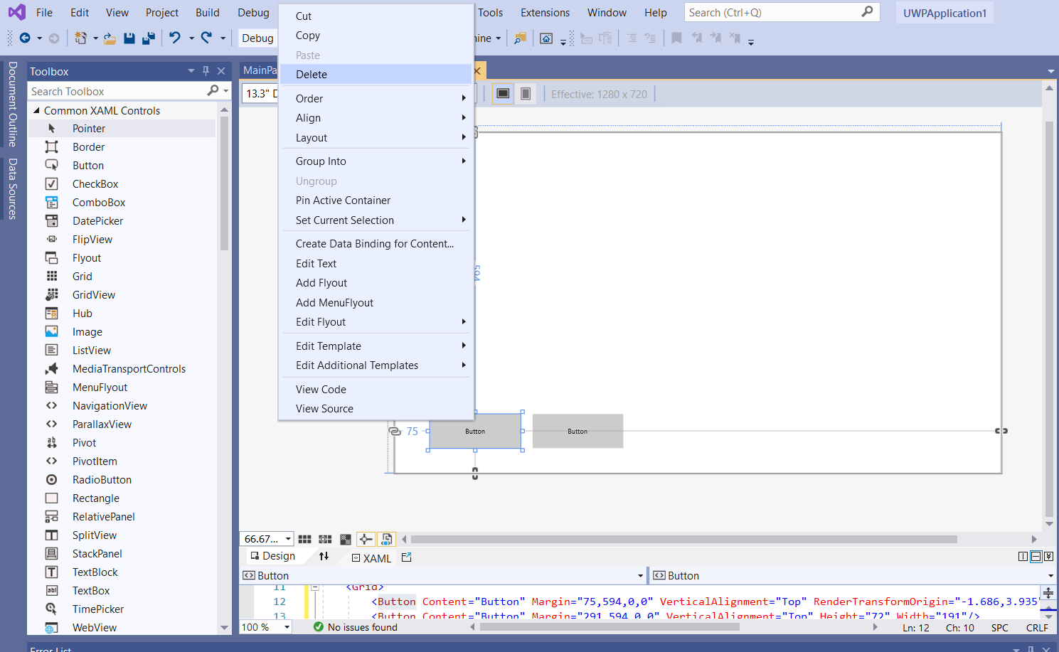You can delete a Toolbox object by clicking on the object then using the **delete key** on your keyboard or by right clicking on the object and selecting the **delete** option.

**The Properties Window**

The Properties window can then be used to change the configuration of the Page and objects added to the Page from the Toolbox.

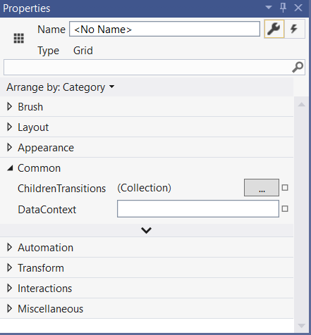

Clicking on a page or an object on the page will activate the Properties window associated with the selected object.

Click on the page and the associated Properties window will be displayed.

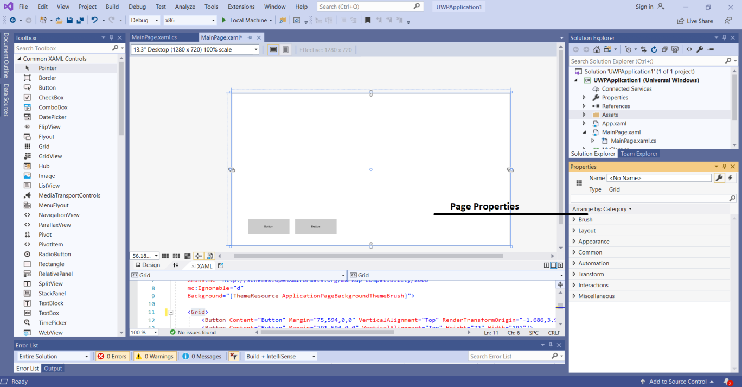The properties window can then be used to change the configuration of the page.

Click on a button and the associated Properties window will be displayed.

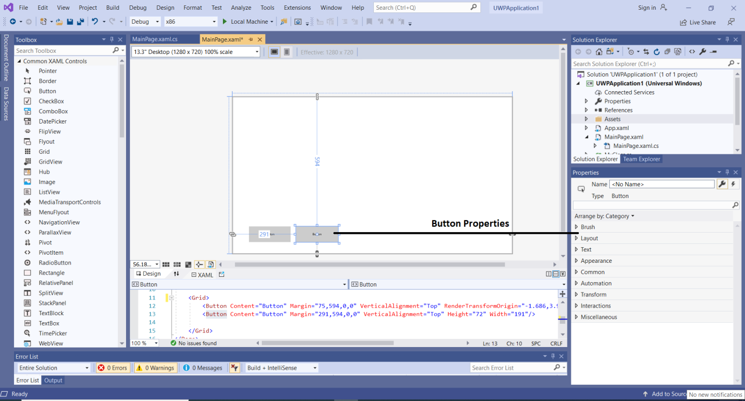The Properties window can then be used to change the configuration of the button.

Note: If the Properties window is not visible. Do you remember how we set up the environment windows (select the **View tab** and **click** on the Properties Window option).

**Just for Fun – Let’s add a background image to the Page Grid**

Note: We will look at page configuration and object usage in some depth later in the course, but for now let’s have a bit of fun by looking at the potential of the environment (a quick-and-dirty example).

When we click on the page we are actually accessing a Grid so let’s add a background image to see what happens to our page.

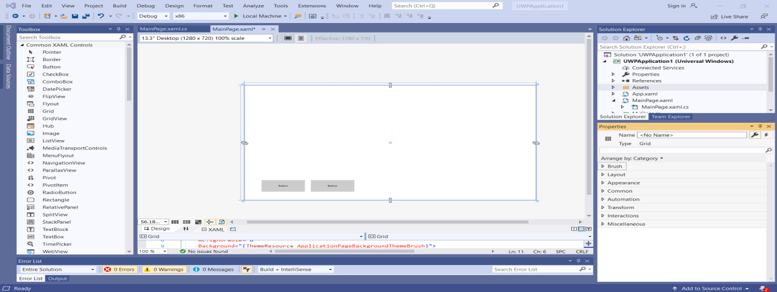First select the page by clicking on it.

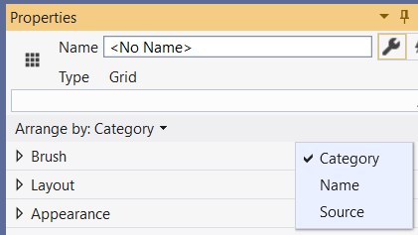To make thing easier for ourselves display the Properties list by **Category**.

If it is not already set up, in the **Properties** window click the **Arrange by Category** option and then select the **Category** item.

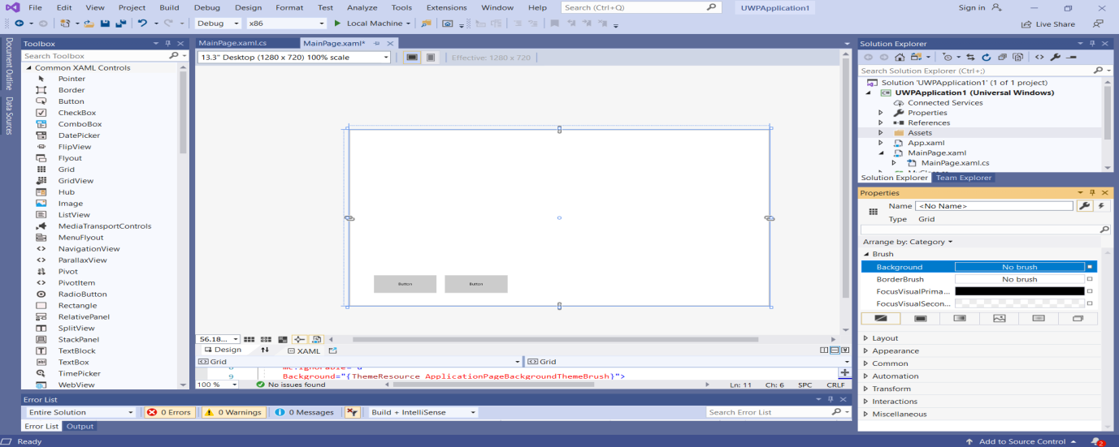Now select the ***Brush*** property in the **Properties** window.

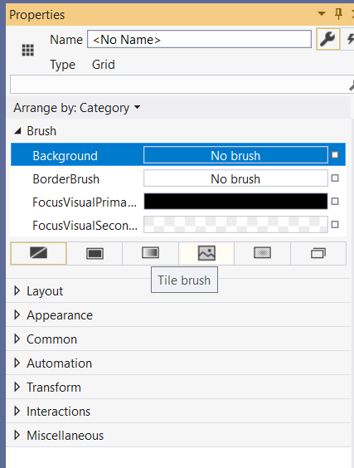

Click on the **Background** option then on **Tile Brush** button.

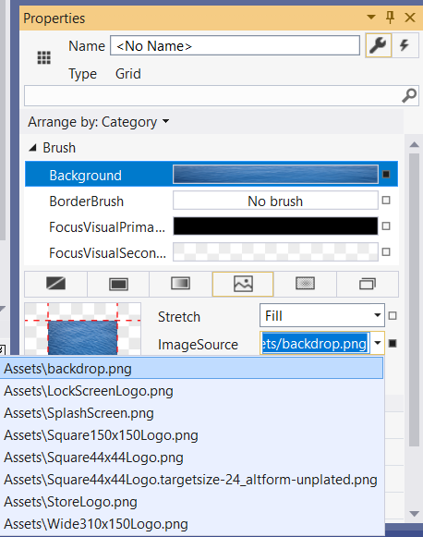

Open the **ImageSource** list box, drop down the list (click on the dropdown triangle at the right side of the box) and select the **Assets\backdrop.png** file by clicking on the list entry.

This is the file we loaded into the Assets file as a resource previously.

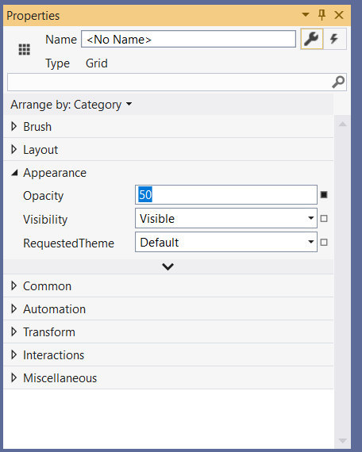

Finally click on the **Appearance** property and set the **Opacity** to 50.

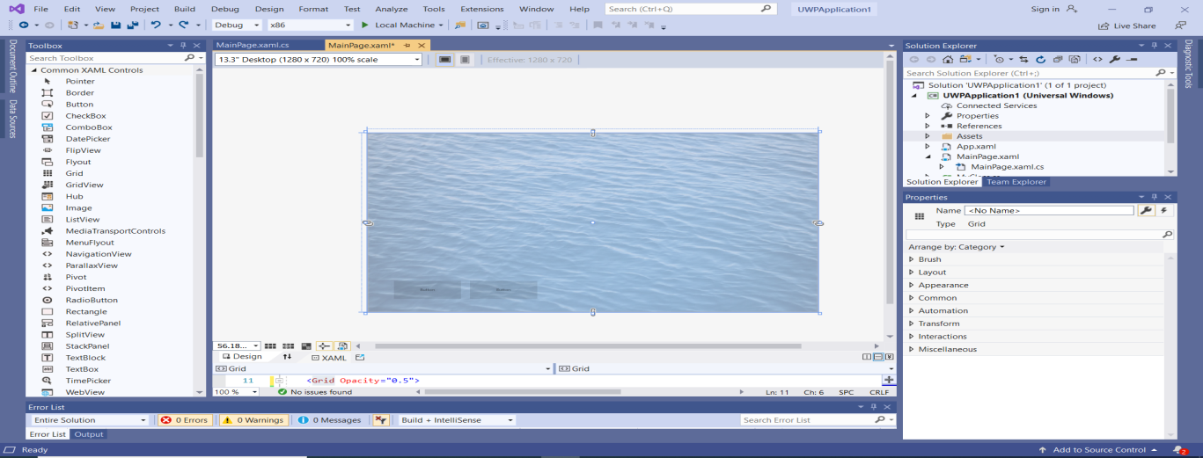We should have the following now.

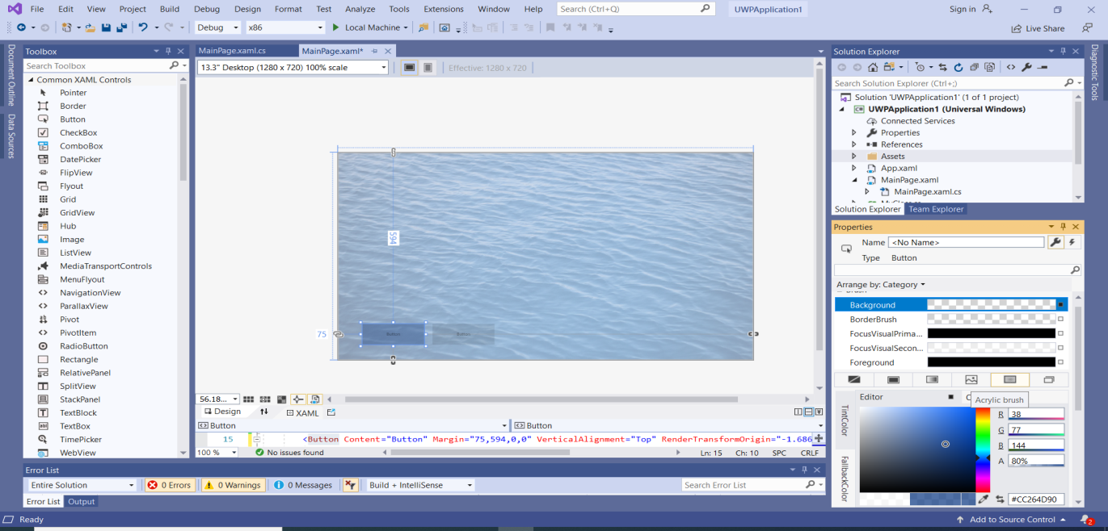Let’s change a button also. Click on a Button on the page. Set the Background to Acrylic Brush and set a deeper Blue colour.

Testing our app. We can quickly test our app by clicking the **green arrow** on the toolbars.

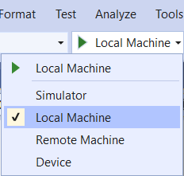

First check the platform is set to local machine, by selecting the **Local Machine** option on the dropdown list.

Now click the green arrow and you should see the following.

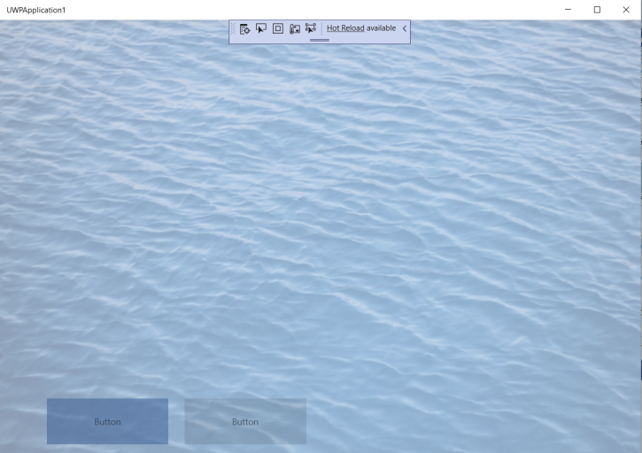

**Exercise 1: Just for Fun**

Add a new file to the Assets folder. The file is in the Resources folder called **sea.gif**.

Now add this resource to the back of your Page Grid and set the Opacity to 50%.

Does this work on a button try it on the background property…

Try some images of your own…

What is the difference between setting the Grid > Brush > Background > Opacity and the Grid > Appearance > Opacity.

Example Project: UWPExercise1

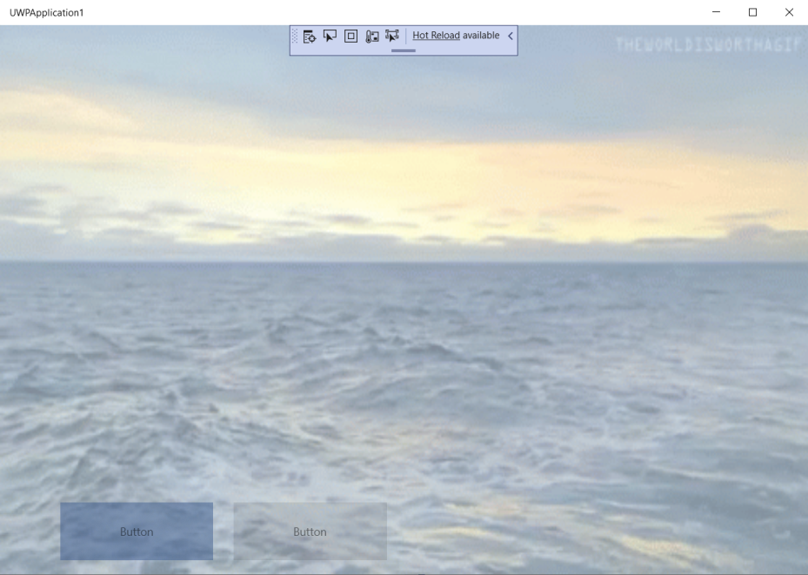

**Using the Code Editor**

We can add C# code to our Pages using the Code Page Editor.

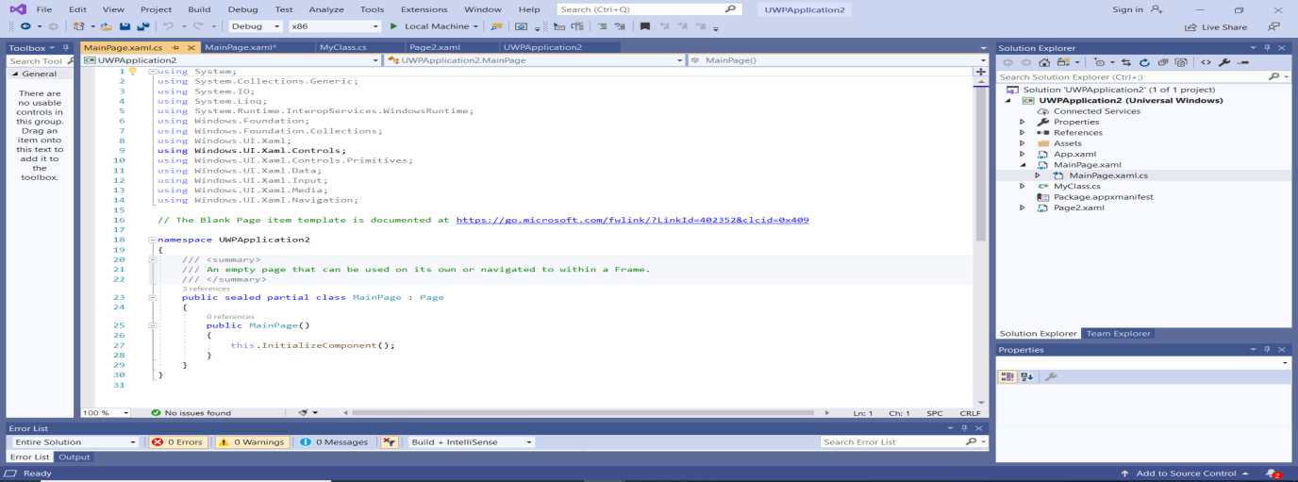We can activate the Code Page by simply clicking on View Code  icon in the Solution Explorer or by clicking on the **MainPage.xaml.cs** window tab.

This page contains the C# code for our page.

|  |
| --- |
| using System;  using System.Collections.Generic;  using System.IO;  using System.Linq;  using System.Runtime.InteropServices.WindowsRuntime;  using Windows.Foundation;  using Windows.Foundation.Collections;  using Windows.UI.Xaml;  using Windows.UI.Xaml.Controls;  using Windows.UI.Xaml.Controls.Primitives;  using Windows.UI.Xaml.Data;  using Windows.UI.Xaml.Input;  using Windows.UI.Xaml.Media;  using Windows.UI.Xaml.Navigation;  // The Blank Page item template is documented at https://go.microsoft.com/fwlink/?LinkId=402352&clcid=0x409  namespace UWPApplication2  {  /// <summary>  /// An empty page that can be used on its own or navigated to within a Frame.  /// </summary>  public sealed partial class MainPage : Page  {  public MainPage()  {  this.InitializeComponent();  }  }  } |

The ‘**using’** keyword allows you to link classes into your code (these classes contain functionality supplied by the environment).

Note how the **{ }** are used to define blocks of code.

In this piece of code we have a ‘**namespace’** (project) called UWPApplication2 which has a Page in it called ‘**MainPage’** with some start-up code (constructor) for the page.

**Extra Info on Namespaces**

A namespace is the container used to group related classes. When you create a project the IDE creates a namespace with the same name as the project.

For basic projects there is little to consider with namespaces as the IDE deals with the project configuration. The only issue you may have is if you copy files from one project to another project, then make sure you change the old namespace name to the new project namespace name.

**Generating Code**

For the sake of this example let’s auto generate some code. Don’t worry about what the code means yet, we will be looking at that in detail over the next few weeks.

Let’s get the button to do something by responding to a click event.

Go to the design window by double clicking the **MainPage.xaml** file in the solution explorer or selecting the **MainPage.xaml Window tab**.

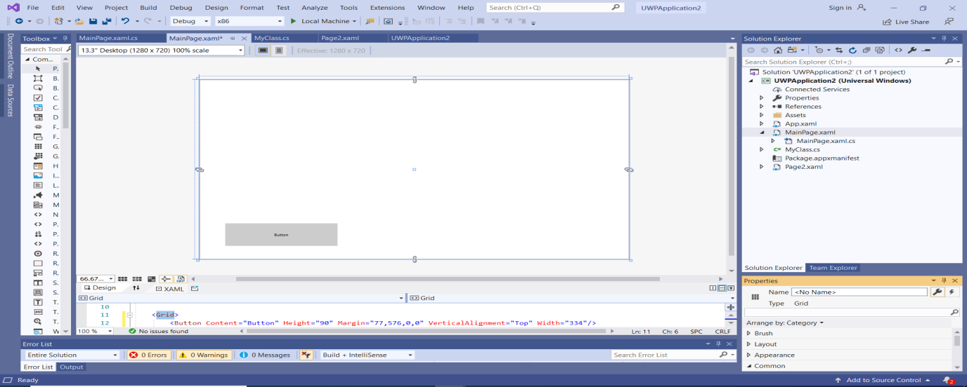For this example I have removed a button and the background on the form by **deleting** the button and setting the **Grid > Brush > Background** to **No Brush**.

Try and do this on your form…..

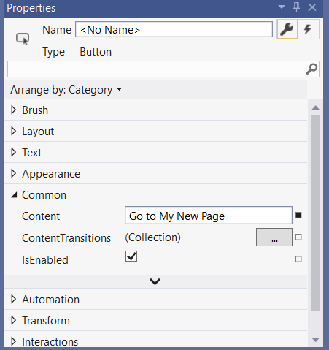So let’s generate some code.

Select the button by clicking on it in the design window. This will activate the properties for the button.

In the **Common >** **Content** property, enter **Go to My New Page**.

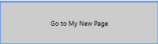When you press the Enter key on your keyboard or move off the property the new setting will take effect.

To auto generate some code for the button first select the **Events ** icon in the Properties window.

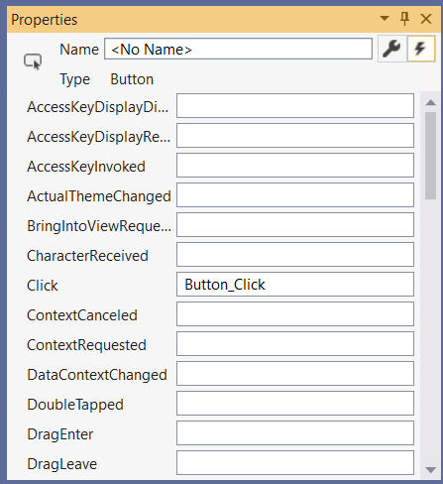

Find the **Click** event in the Properties Window Events List.

Now **double click** in the name field next to it **Click** event.

This will auto enter the **Button_Click** name fortheevent and also load the Code Page with the auto generated code for the click event.

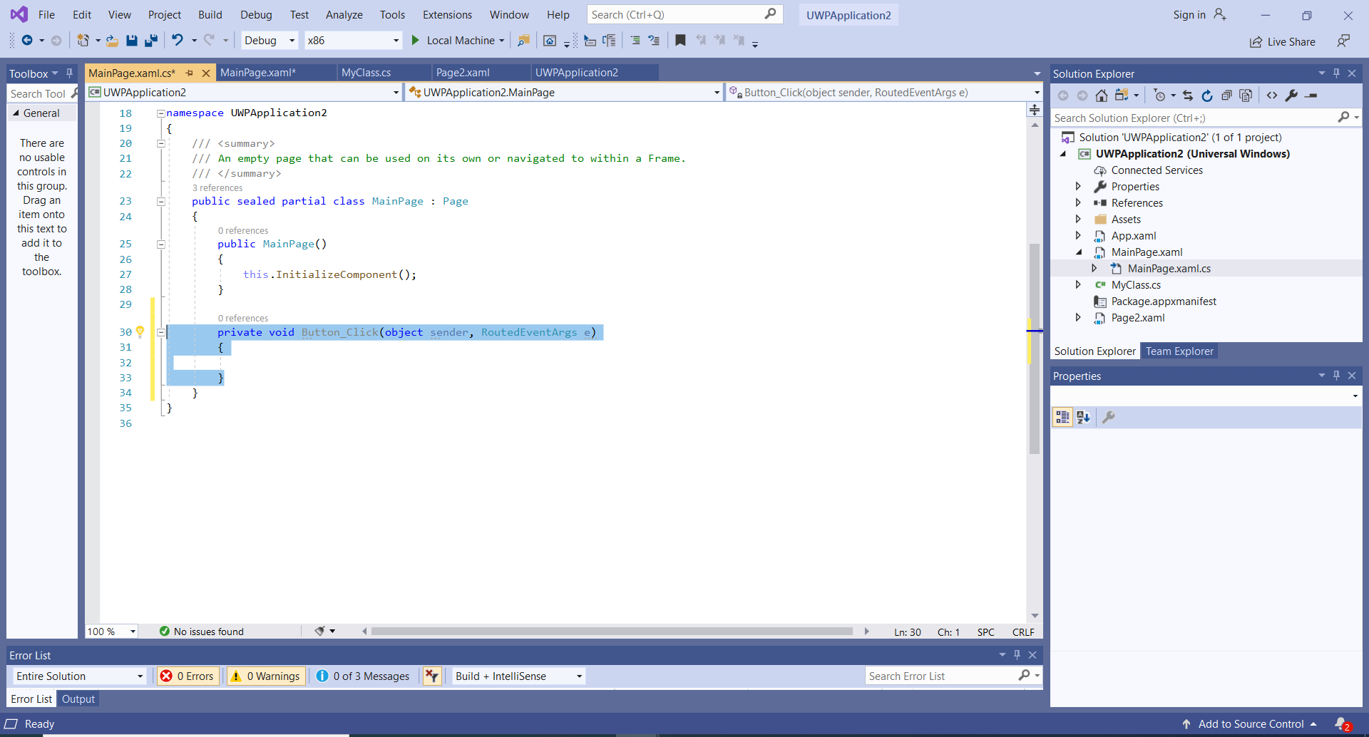The event generated is called **Button_Click**, this is where we can put any code that we want to run (something to happen) when the button is clicked.

The click event fires when the button is clicked, any code we put inside the event will also be run.

If we add the following code to the event method we will be able to navigate to the **Page2** page we set up earlier in this tutorial.

Note: If for any reason you have deleted the Page2.xaml page, then re-add it to your project, see the previous section Adding Pages to a Project.

When adding code to a project, sometimes copied code gets corrupted or the characters are misinterpreted depending where you have copied the code from. If this happens then you will need to type in code.

C# is also case sensitive, the compiler will see **aPage** and **apage** as different things.

Add the following code that is highlighted to your MainPage.xaml.cs file in the correct places.

|  |
| --- |
| private void Button_Click(object sender, RoutedEventArgs e)  {  this.Frame.Navigate(typeof(Page2));  } |

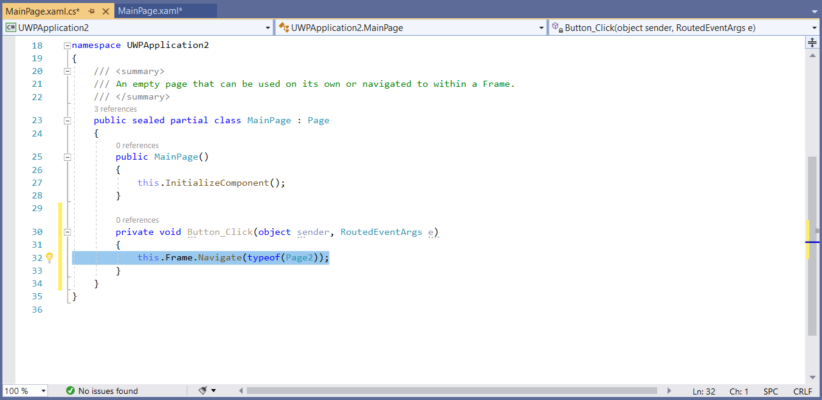

**Project Execution**

Now we have some code in our project let’s try and run it.

The process is to:

* Build the code, this allows the compiler to check for any errors.
* Run the code, the form will run on our desktop.
* Stop the application from running, so that we can continue coding.

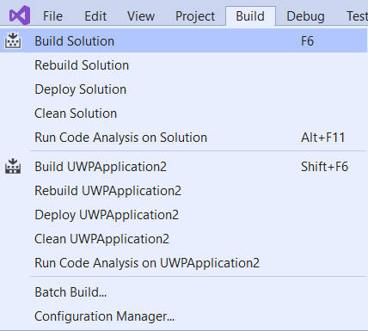**Building the Application**

To build an application select the **Build > Build** **Solution** option. If you need to completely rebuild (overwrite the build in memory) then use the Rebuild Solution option.

This will build the solution and display any errors (in the error list) if the code is wrong.



Note: If the Error List is not visible then select the **View > Error List** option to display the window.

**Running the Application**

There are several options that allow us to run the application.

First check the platform is set to local machine, by selecting the **Local Machine** option on the dropdown list.

Click the **Start**  arrow on the toolbar.

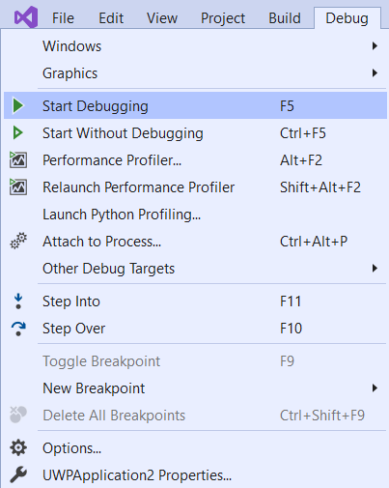

Or selecting the **Debug > Start** **Debugging** option.

Or press **F5 key** on your keyboard.

Any of these options will run the application.

When the application is running you can click the **Go to My New Page** button on the **MainPage** page to display the **Page2** page.

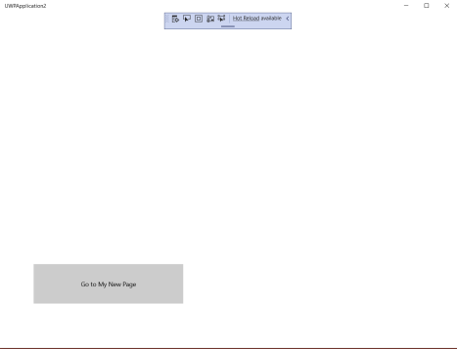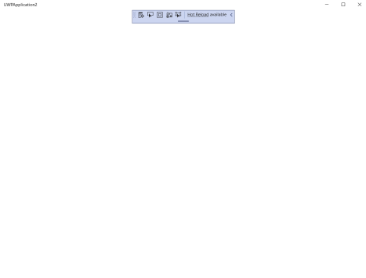

**Stopping the Application Running**

To stop the application running any of the following methods can be used.

Close the application itself (by whatever mechanism you have designed into the application), for this application, click the close button (**X**) on Form1.

Click the Stop Debugging square  .

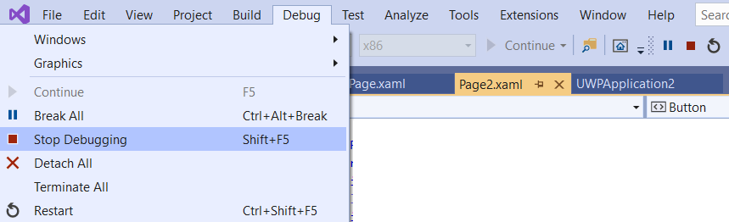

Select **Debug > Stop Debugging** option

Press **Shift + F5** keys on your keyboard.

**Exercise: Introduction to Visual Studio 2019**

Work through the each of the following sections of the course material ***again*** and produce a Universal Windows Platform Project, call the project **MyFirstProject**.

* Opening the Development Environment
* The Development Environment
  + Creating a UWP Project
  + Saving a Project
  + Closing a Project
  + Open an Existing Project
  + What’s in a Project Workspace?
    - Moving Between Windows
    - Working with Windows Studio Windows
    - Using the Solution Explorer
      * Adding a Page to a Project
      * Adding a Class to a Project
      * Add a Resource to a Project
    - Using the Page Designer
      * The Design Window
      * The Properties Window
      * Adding an Image to a Page
    - Using the Code Editor
      * Generating Code
* Project Execution
  + Building the Application
  + Running the Application
  + Stopping the Application Running
* Extend the notes
* Using your current code implement of a way to get back from Page2 to the **MainPage**.
* Research - We can also use something called a HyperlinkButton. See if you can set up one on each page to switch pagers (like buttons) when clicked.

Example Project: UWPApplication2

**IDE Coding Features**

In this section we will look at several useful features of the Integrated Development Environment.

Note: Use the **IDECodingFeatures** project to examine the IDE coding features.

**Comments**

Comments are added to code to explain what is happing and make your code readable. Adding a comment makes the compiler ignore the text associated with it. Comments appear as green text in the code editor.

To comment a single line use the **//.**

|  |
| --- |
| // A single line comment |

To comment a block use the /* */ it has two formats.

|  |
| --- |
| /*  * A block of comments  * A block of comments  */  /*  A block of comments  A block of comments  */ |

We also have a special format that auto generates the header for a method, typing **///** above the method auto generates the header block for you. We then fill in the relevant information ourselves.

|  |
| --- |
| /// <summary>  /// </summary>  /// <param name="inputA"></param>  /// <param name="inputB"></param>  /// <returns></returns>  /// <summary>  /// A test method  /// </summary>  /// <param name="inputA">Integer used in calculation</param>  /// <param name="inputB">Integer used in calculation</param>  /// <returns>Result of the calculation</returns>  public int test(int inputA, int inputB)  {  return inputA + inputB;  } |

Comments can be added or removed using the comments options in the tool bar.





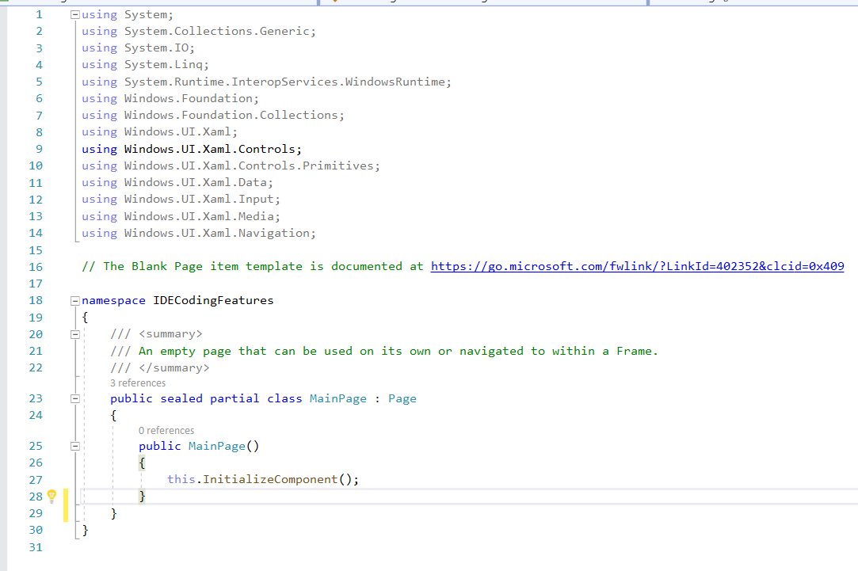**Indentation**

We use indentation to make our code readable.

Tab across after each bracket to show the structure of the code clearly.

Blocks of code can be tabbed using the indent options on the toolbar.

To do this we first need to add the Decrease Line Indent and Increase Line Indent buttons to our toolbar.

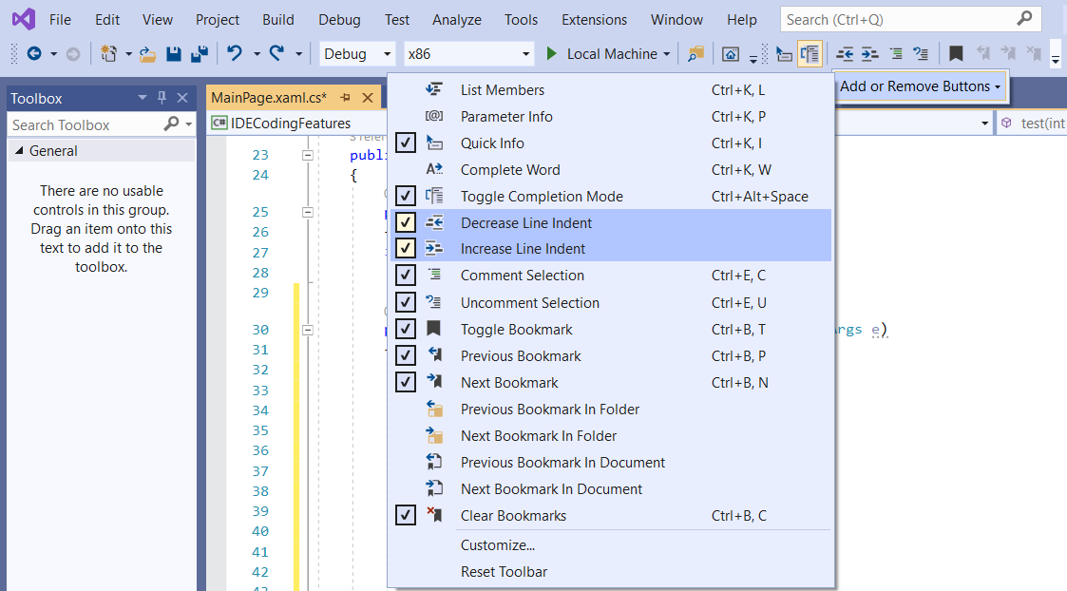Select the Add or Remove Buttons dropdown  on the toolbar and the tick the Decrease Line Indent and Increase Line Indent options.

Now we can use the indent options to tab our blocks of code.

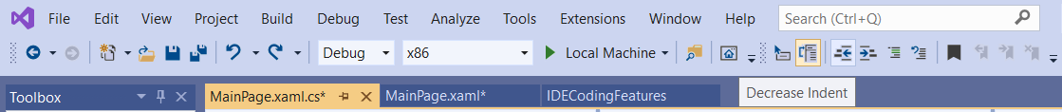



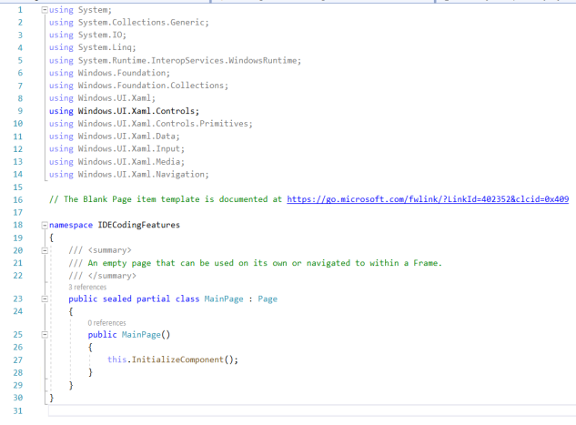**Line Numbers**

Line numbering is placed down the left hand side of the Code Window.

It is useful for finding specific lines of code.

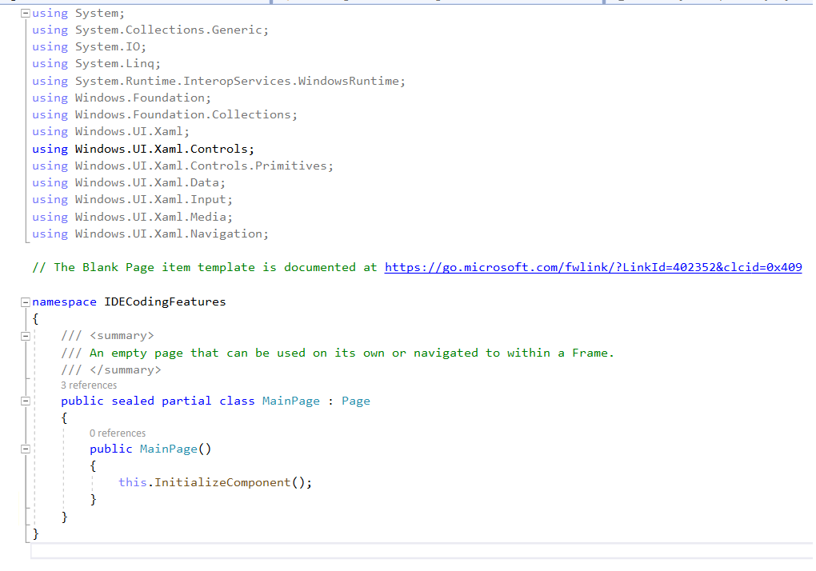

Some programmers like to remove it from the code window. To do this, you can select to switch it on or off in the Text Editor options.

In the **Tools menu > Options section**, select the **Text Editor > All Languages > General page.**

Tick the **Line numbers** option to show line numbering or untick the **Line numbers** option to hide the line numbering, then click the **OK** button.

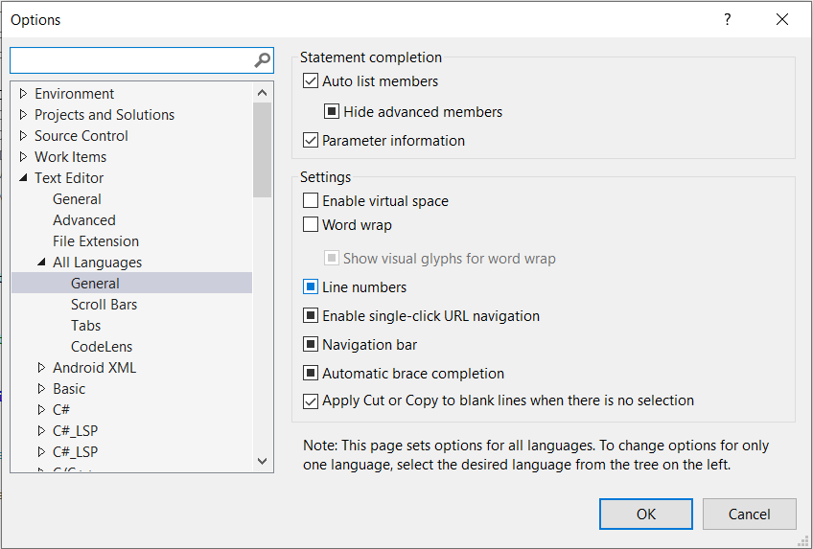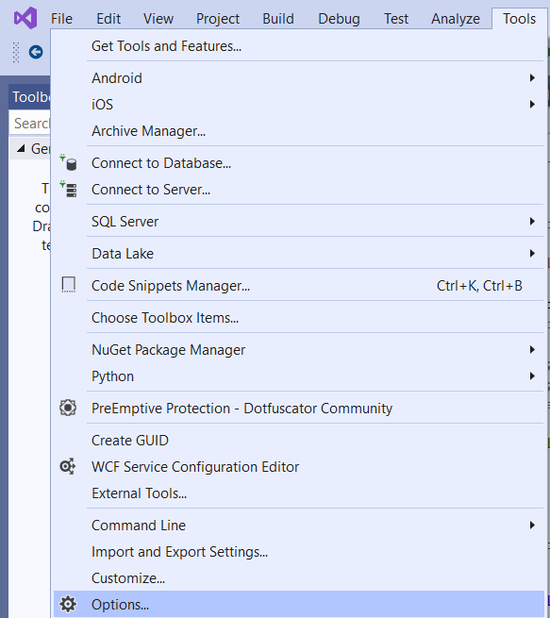

**Bookmarks**

When a project gets to a certain length it tends to be difficult to keep track of the code.

One of the features offered by the IDE is the bookmark option , which can be used to place a marker next to a line of code.

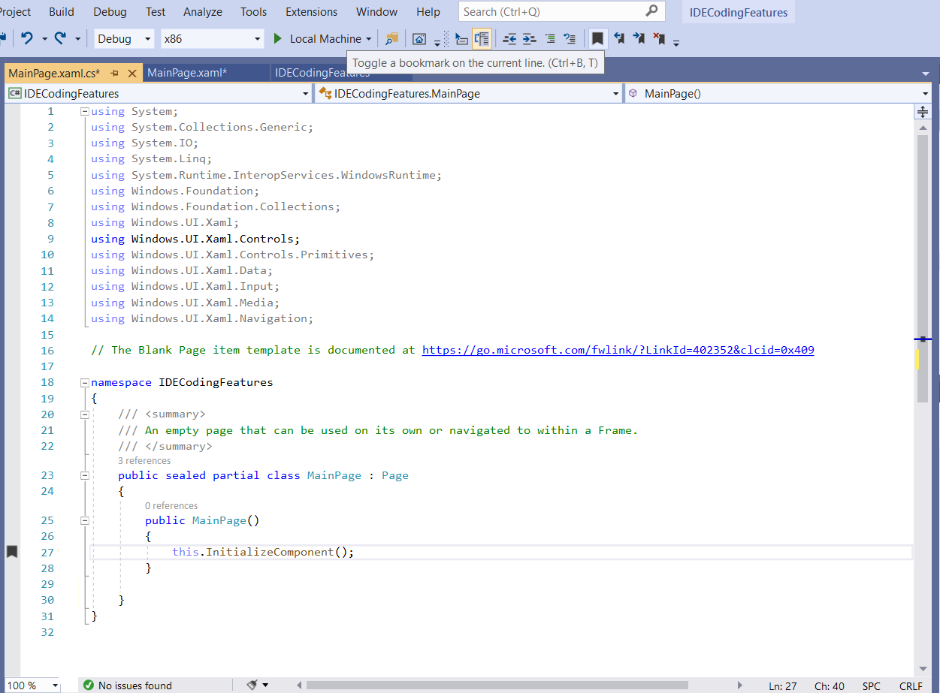To set a bookmark **place the cursor on the line of code** and thenselect the **Toggle Bookmark** option on the toolbar**.**

Bookmarks can be removed by placing the cursor on the line where there is a bookmark and selecting the **Toggle Bookmark** option or the **Clear All Bookmarks** option can be used to clear all the bookmarks in the file.



You can move forwards and backwards through the Bookmarks in a file using the move bookmark options.



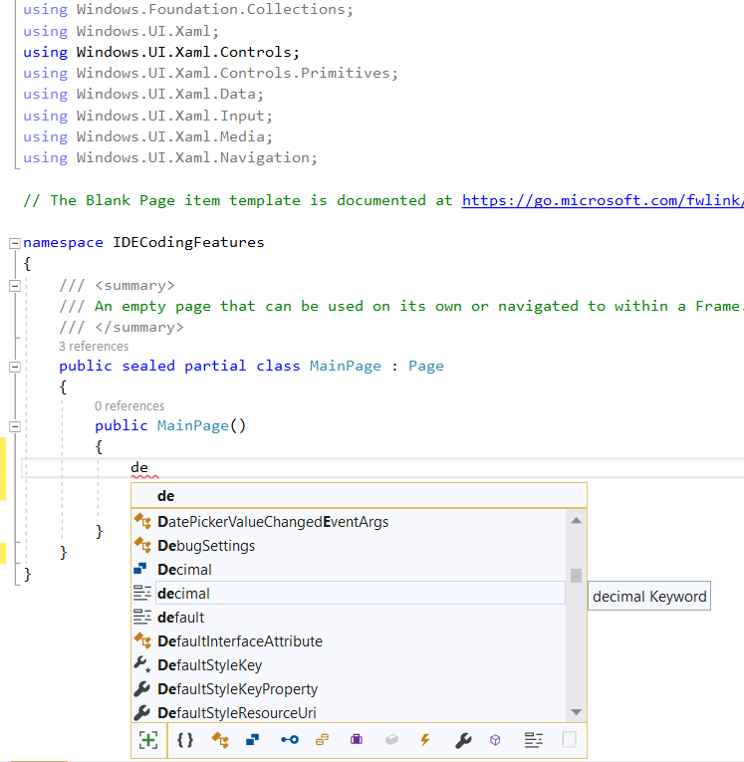**How IntelliSense Works to Complete Code**

IntelliSense is activated as you type in keywords, data types, variables, objects and classes.

The IntelliSense offers a completion list of items that match what you are typing.

Highlighting an item in the completion list will activate a tool tip with information about the item.

Notes: Using the TAB key to select an item keeps you on the same line.

The Ctrl key can be used to set the list to semi-transparent so you can see the code behind it.

**How to Use the #region / #endregion Directives**

The **#region** and **#endregion** directives (pre-processor commands) allow us to specify a block of code that we can expand or collapse.

The format for the #region directive is:

|  |
| --- |
| #region Name  // Code block  #endregion |

Where the ***Name*** is the region you want to define.

A region must be terminated by a #endregion directive.

The following example shows the use of the #region directive with the code blocks expanded and collapsed.

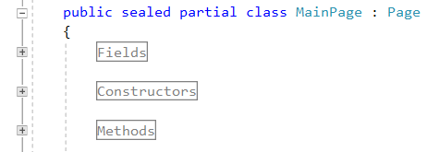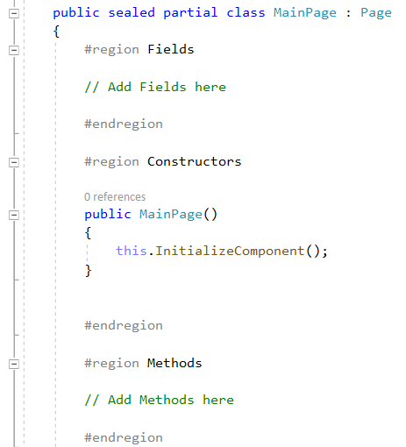

**Getting Help**

The MSDN library is a vast repository of online resources and help files.

The help files can be accessed in a couple of ways.

Using the **F1** Key on your keyboard.

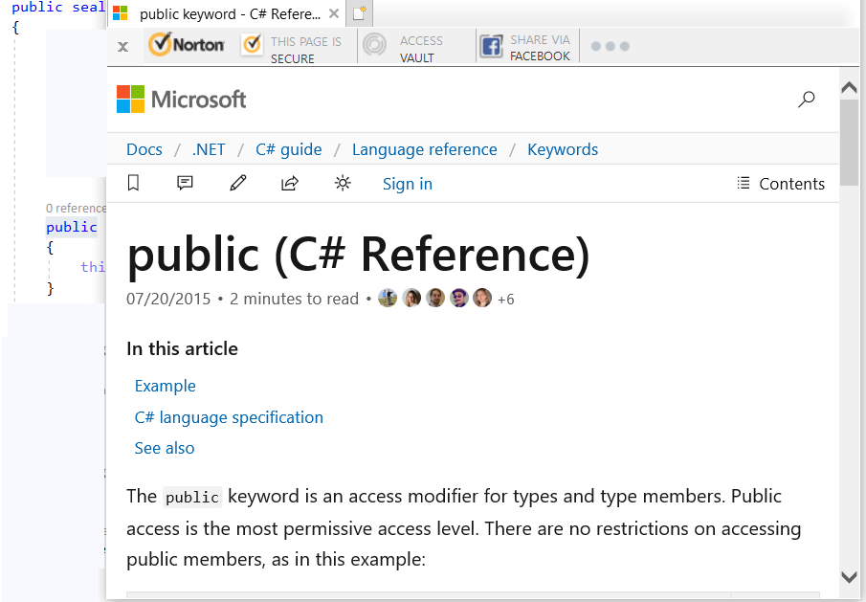Highlighting the text in the code editor and pressing the **F1** Key your keyboard.

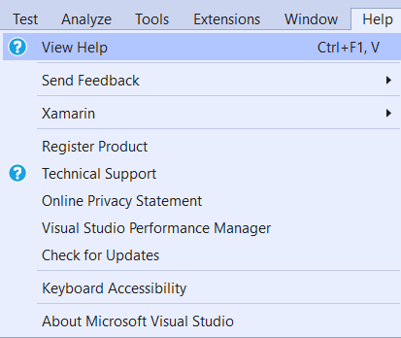

Selecting the **Help tab > View Help** list option.

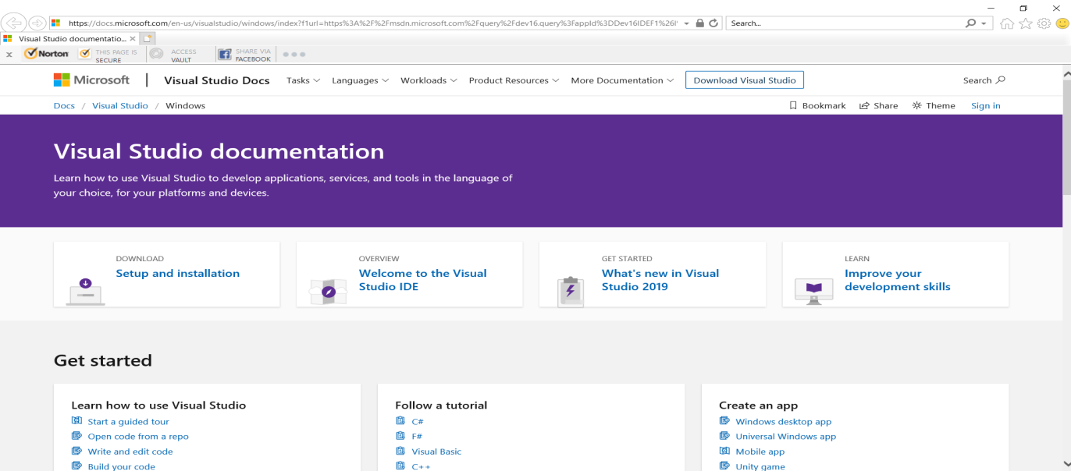The help panel has a search facility that gives you access to the whole Microsoft repository of technical information. You can search for an item by entering the search string into the input box and pressing the search icon.

**How to Refactor Code**

Refactoring is the technical term for changing the name of something and making sure that it is changed throughout your code.

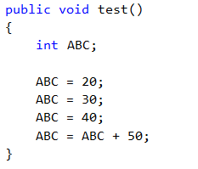Say we had a variable called ABC and we wanted to give it a more intuitive name creditRate, we would need to change all instances of ABC in our code to creditRate.

The IDE has a feature that makes it easy for us to refactor our code.

Here the code shows a variable called ABC

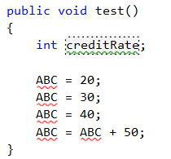

When we change (type in) the variable name to creditRate a dotted rectangle will appear around the variable name. This signifies that the compiler has recognised several other instances of the variable that need changing.

Place your cursor over the **dotted rectangle** and light bulb icon will appear.

Place your cursor on the **light bulb arrow** and the refactoring list will become accessible.

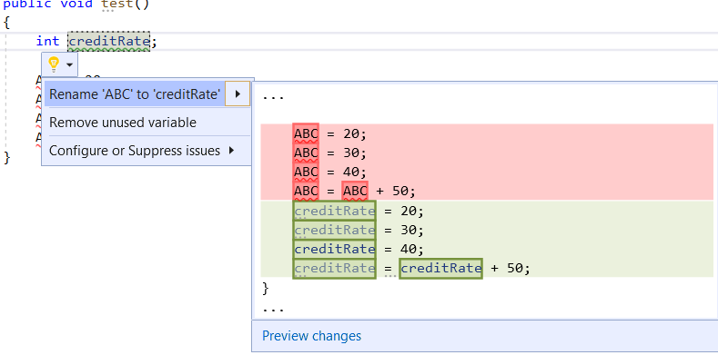**Click** on the **Rename** option and the changes will take place to your code.

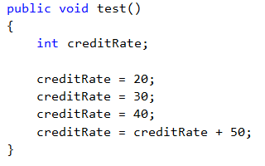

All instances of ABC will now be renamed creditRate.

Note: There is nothing stopping you using a search / replace if you prefer.

**Exercise: IDE Coding Features**

Use the IDE Coding Features section as a reference to work on this exercise.

Use and extend the **FeaturesExercise** project for this exercise, we will be working in the **MainPage.xami.cs** file.

Work through the each of the following tasks updating the **FeaturesExercise** project **MainPage.xaml.cs** file where required:

1. ***Line Numbers*** – Switch the line numbers on and off on the MainPage.xaml.cs code. Now decide which you prefer and set that option.
2. ***Indentation*** - Indent all the code in the MainPage.xaml.cs file.
3. ***Bookmarks*** –Set a Bookmark on every line with an open curly bracket **{** and closed curly bracket **}**.
4. ***Comments and Help*** – Wherever you see comments in the code in this format **// What does this mean (int)** access the Help files (highlight and F1 key) and update the comment with what it means.

e.g. explain what int means.

// What does this mean (int)

int a;

1. ***#region / #endregion Directives*** – Setup the following regions in the MainPage.xaml.cs file in the Refractor code method:

* First Change
* Second Change
* Third Change

1. ***Refactor Code*** – Refactor all the following variables:
   1. Change ABC to aNumber
   2. Change XYZ to aDecimalNumber
   3. Change addsomething to addSomeNumbers
2. **IntelliSense** – Experiment with the IntelliSenc feature.

Example Projects: IDECodingFeatues

FeaturesExercise

FeaturesExerciseSolution

FeaturesExerciseText

FeaturesExerciseSolutionText

**How to Debug an Application**

There are times when our code is not working correctly or is just full of errors.

That is when we need to debug our code.

The IDE has several features that report on the status of code and allow us to observe its operation.

Note: Use the **HowToDebug** project to examine the debugging coding features.

**Error List Window**

The first indication we have an error is when we code the application or build the application.

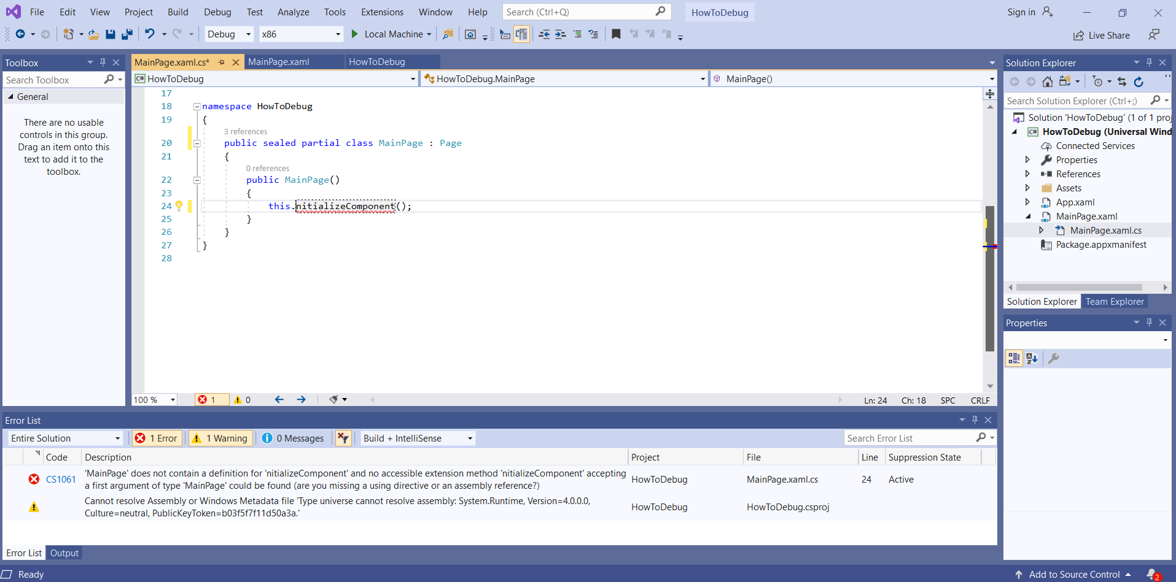Any errors (syntactical) will appear with a red line underneath them and an error message will appear in the Error List that explains the error/s.

Double clicking on the error message will (most times it depends on the nature of the error) move the cursor to the line of code that generated the error.

The error here, as the message states ***“MainPage does not contain a definition …”***, isbecause inadvertently we have deleted the ***I*** in the ***InitializeComponent();*** code.

Syntactical errors tend to be easy to spot as they are generated by typos or using the wrong syntax when coding.

If the message is ambiguous, copy part of the message and search in the MSDN help for a solution.

We will look in depth as C# programming and identify any potential syntactical pitfalls as we progress through the language.

At this stage in the course some of the things to look out for are…..

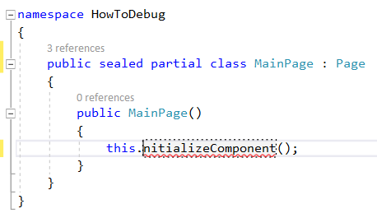***Typos*** - code spelling errors or incorrectly named elements are prevalent when you are editing example code.

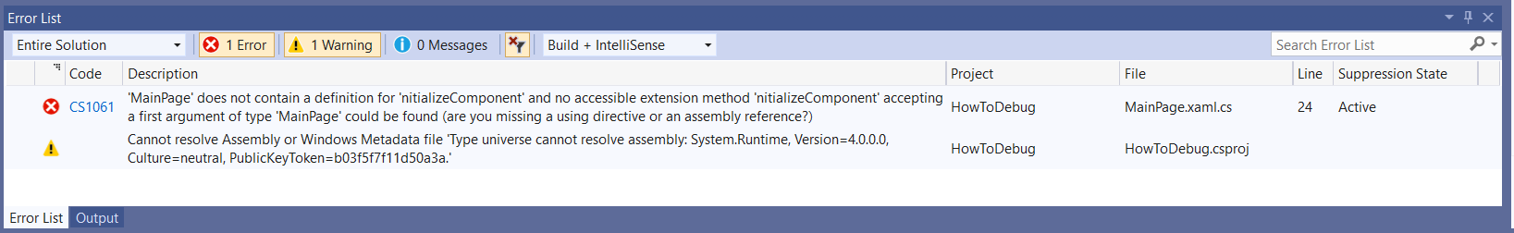

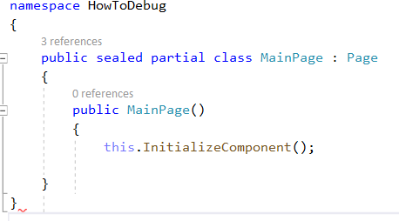

***Curly Brackets (braces)*** - **{ }** - these come in pairs for every open **{** bracket in your code there needs to be a closed **}** bracket.

Curly brackets denote a block of code that does something.

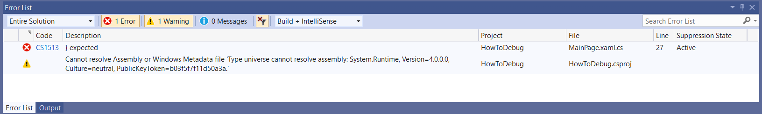

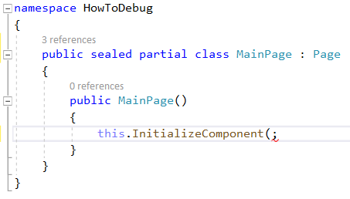***Round Brackets (parentheses)*** - **( )** - these also come in pairs for every open **(**bracket in your code there needs to be a closed **)** bracket .

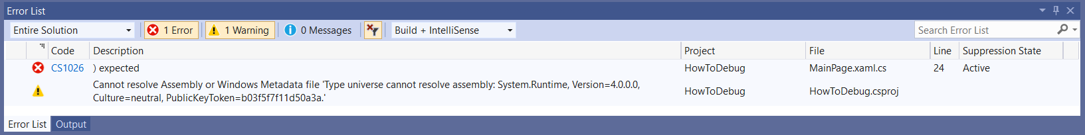Round brackets have various uses in C# this will become apparent as we progress throughout the course.

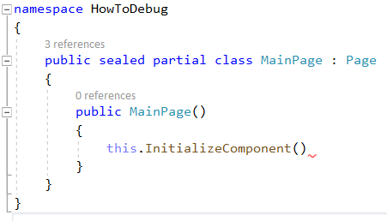

***Semicolons*** - **;** - a line of code may require a semicolon at the end.

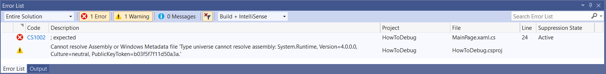

**Breakpoints, Locals Window and Watch Window**

Logical errors are trickier to track down.

They tend to be misinterpretations of the logic or algorithms used in the application.

The best way to track down a logic error is using the debugging options to walk through the application code as the application is running.

To do this, we need to set a breakpoint in our code, start the debugger and setup the locals and watch windows to view the code.

**Set a Breakpoint**

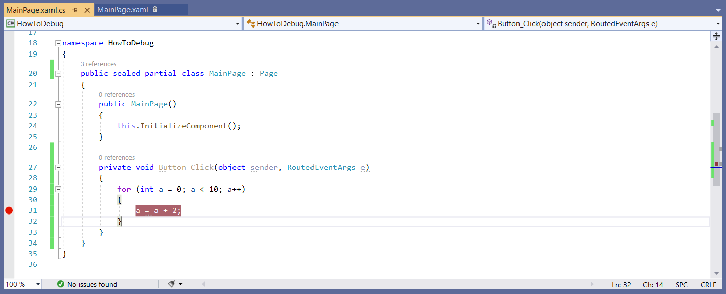A breakpoint can be set by ***clicking in the left margin*** on the line of code you need the break point.

Note: You can only set a break point on a line with code on.

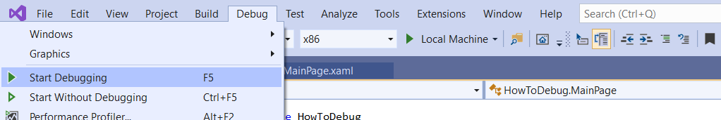**Start the Debugger**

The debugger can be started by selecting the **Debug > Start Debugging** option.

When the flow through the code reaches the breakpoint (in this example when the button is pressed on your application that is being run) the debugger stops the application.

**Setup the Locals and Watch Windows**

The Locals (displays all the local variables to watch) and Watch (you pick what to watch) windows can be set up now.

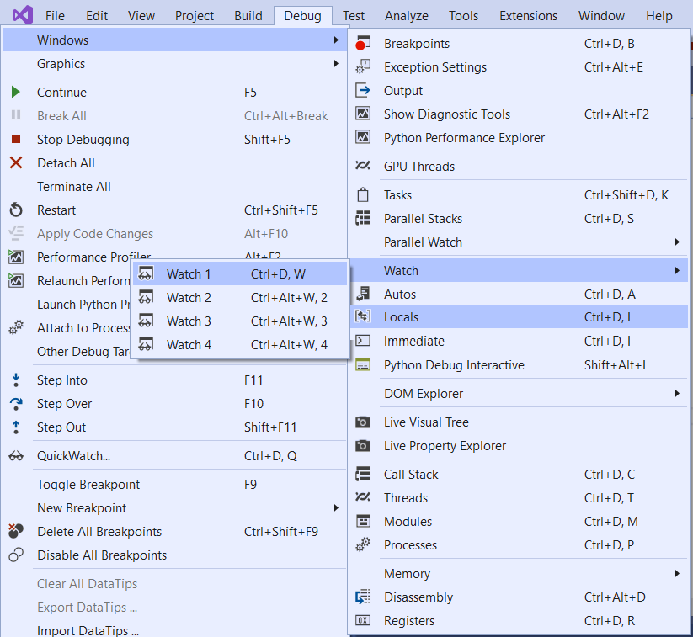If the Locals and Watch windows are not visible select the **Debug > Windows > Watch 1 and Locals** options. These options become visible in the Windows list when Debug is running.

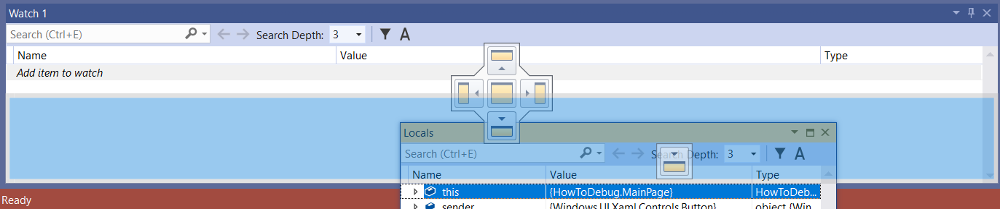Remember that we learned how to move windows in the **Working with Visual Studio Windows** section, so let’s organise the Locals and Watch windows so that we can see both windows clearly.

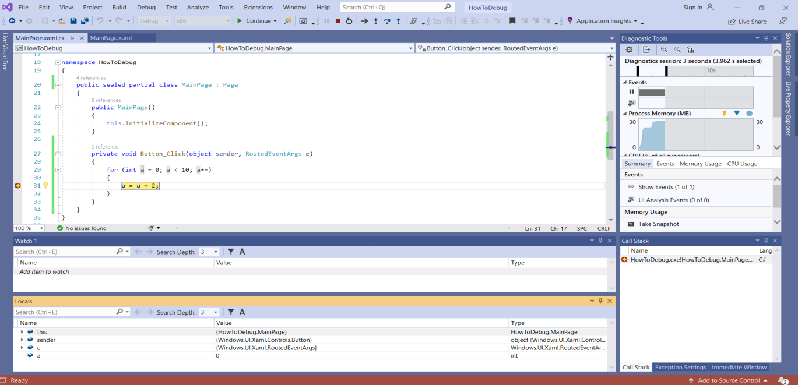

The Locals window will display any current local variables.

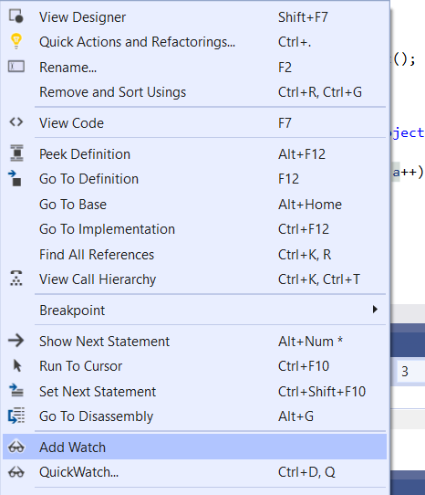In the Watch Window you can select what you want to watch.

To select a variable **highlight the variable** (in this example ***a***) in the Code Window, then **right click** on it and select the **Add Watch** option.

The variable will then appear in the Watch window.

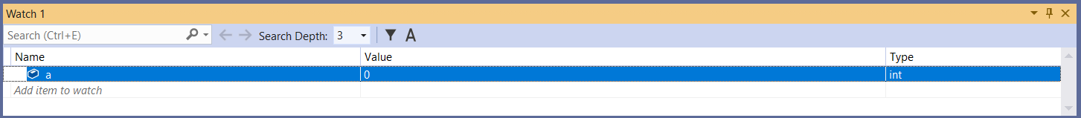

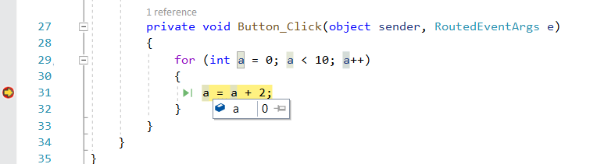It is also possible to see the value in a variable by holding the mouse pointer over it.

**Stepping Through the Code**

The debug toolbar has several useful options for stepping through code.

******Here we will look at the most commonly used options Continue, Stop Debugging, Step Over, Step Into and Step Out. These will appear on the Toolbar when debugging.

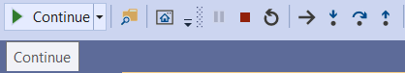***Continue*** - Pressing the **Continue** option (F5) will run the code until the next break point.

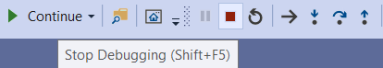

***Stop Debugging*** – The **Stop Debugging** (Shift + F5) option stops the debugging process completely.

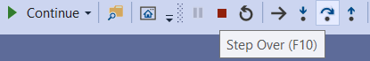***Step Over*** – The **Step Over** (F10) option allows you to step through the code line-by-line.

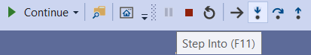***Step Into*** – The **Step Into** (F11) option allows you to step into the code.

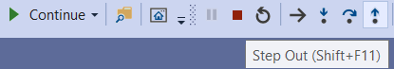

***Step Out*** – The **Step Out** (Shift + F11) option allows you to step out of any code stepped into.

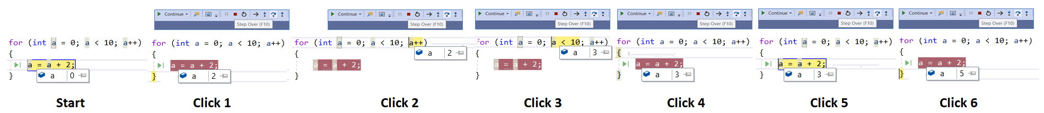If we step through the following code using the **Step Over** option we can see how the value in the variable **a** changes each time we click the **Step Over** button.

**Exercise: How to Debug an Application**

Use the How to Debug an Application section as a reference to work on this exercise.

Use and extend the **HowToDebugExercise** project for this exercise, we will be working in the **MainPage.xaml.cs** file.

Work through each of the following tasks updating the **HowToDebugExercise** project **MainPage.xaml.cs** code file where required:

* ***Error List Window*** – Check the **Error List** window for syntactical errors and solve the following errors (remember clicking on the error in the ErrorListwindow will bring you to the line of code where the error is):
  + ***Typos*** – Solve all the typo errors in the code.
  + ***Curly Brackets*** – Add any missing curly brackets to the code.
  + ***Round Brackets*** - Add any missing round brackets to the code.
  + ***Semicolons -*** Add any missing semicolons to the code.
* ***Stepping Through the Code*** –Expand the ***Stepping Through Code*** region (in the MainPage.xaml.cs code file) and you will see three break points have been set to help you step through the code.
* Start the Debugger.
* Click on the **Start** **Debug** button when the page loads.
* Set up three variables in the **Watch** window, **countA**, **countB** and **countC**.
* Use the **Step Into** option to see how the variables **countA**, **countB** and **countC** change with each click.
* Note how using this option takes you into several blocks of code.
* When you have stepped through all the code (the page will wait for the Start Debug button to be clicked) **Stop** the Debugger.
* Now **Start** the Debugger again and click on the **Debug** button when the page loads.
* Note what happens as you use the Step Over, Step Into and Step Out options.
* Investigate how the Step Into, Step Over and Step Out options differ from each other.

Note: If you find the exercise difficult use the **HowToDebugExerciseSolution** project to help find the errors by comparing the Form1 files in both the projects.

Example Projects: HowToDebug

HowToDebugExercise

HowToDebugExerciseSolution

**Appendix A – For home Use**

**Checking the build and setting the developer mode**

Prior to clicking OK on the build window it may be worth checking a couple of configuration options on your home system.

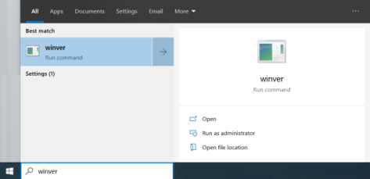Your projects should be built on the latest (or close too) Windows 10 version.

You can check the Windows 10 version on your laptop by typing **winver** into your Windows search box and running the winver programme.

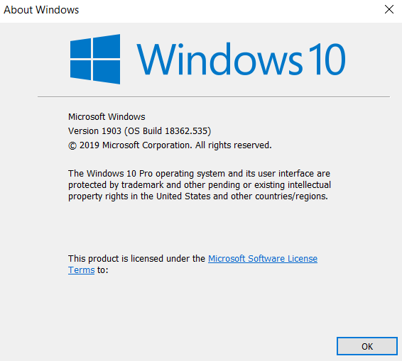

This will display the current Version and Build of your Windows 10 download.

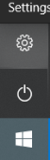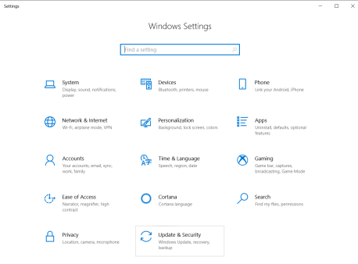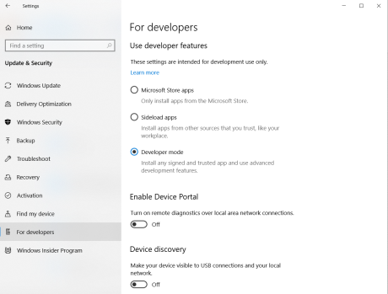To develop on the Universal Windows Platform you will need to set the **Developer mode** to **on** your laptop, so it may be time to check you have this set up.

Select the **Setting** option from your Desktop start icon.

On the **Windows Settings** screen click on the **Update & Security** option.

In the Update & Security lists select the **For Developers** option and click the **Developer mode** option.

**Appendix B – Extras**

***Reference*** – Microsoft Help Site – [https://docs.microsoft.com/en-us/visualstudio/get-started/visual-studio-ide?view=vs-2019]

**Squiggles and Quick Actions**

Squiggles are wavy underlines that alert you to errors or potential problems in your code as you type.

These visual clues enable you to fix problems immediately without waiting for the error to be discovered during build or when you run the program.

If you hover over a squiggle, you see additional information about the error. A light bulb may also appear in the left margin with actions, known as Quick Actions, to fix the error.

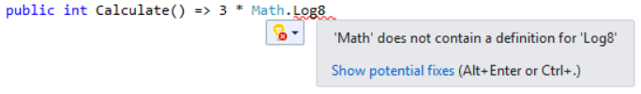

**Go To Definition**

The Go To Definition feature takes you directly to the location where a function or type is defined.

Right click on the item to get the menu to popup.

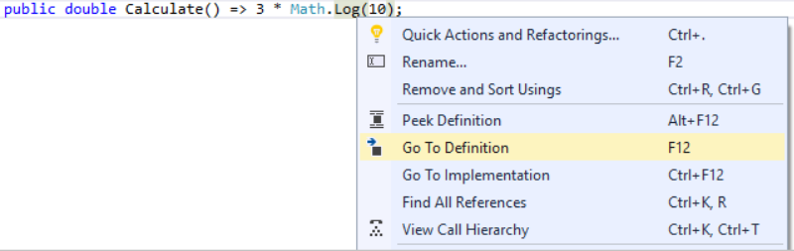

**Peek Definition**

The **Peek Definition** window shows the definition of a method or type without actually opening a separate file.

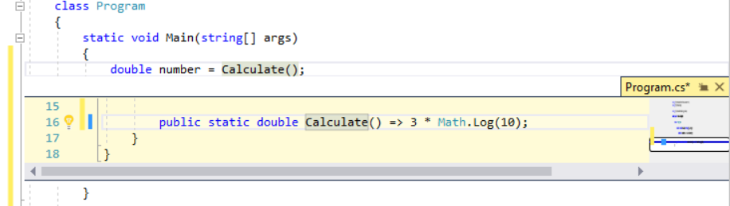

**Appendix C – For Lab Use**

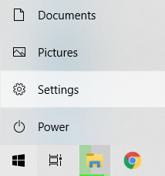When using the labs we need to set the desktop background colours to ***Light*** as this has an effect on our UI development displayed Pages.

To do this…..

In the settings, click on the window icon (bottom left of the screen) and select the Setting option.

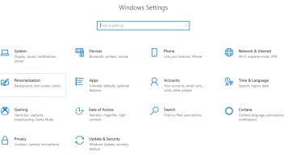

Select the Personalization option.

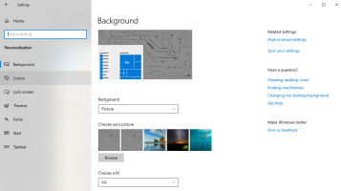

Then the Color option.

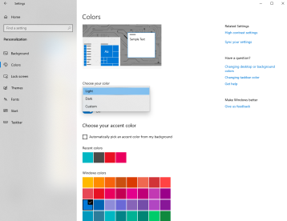

Finally select the Light option.

**Appendix D – My Notes**

Add your own notes here.